MY EXPERIENCE IN GERMANY

ABDALLAH MZUNGU CHIMERAH
Acknowledgement.
I would like to acknowledge the following for making my Germany trip a success;
Edith Miano and Dr. Rukia from Pwani university for giving me the opportunity and believing in me. Thank you so much.
Simone Martin for giving us that warm welcome from the first day until when she left for Australia. I’m so grateful and we enjoyed your company.
Prof. Sissi Closs for also giving us the opportunity and also taking care of everything from the begging of it all to our stay in Germany.
Belinda and Miriam when they took over from Simone were very supportive to the end. They planned and organized everything.
And finally, the BWS also for giving us the opportunity to come to Germany for the program. Thank you.

The preparations
The information about a possible visit to Germany reached me through my lecturer Dr. Rukia Harith in our class. Five of us in the class were given chance to apply, I don’t know what happened with others but I submitted my application. Fortunately, on 5th December, 2018 I received a call from Edith Miano telling me to prepare my travel documents as I was supposed to travel to Germany. It wasn’t easy, because I hadn’t applied for a passport yet, and in Kenya such activities might take 6-8 moths. My application wasn’t easy, and I had already given up when I received a call that I finally had the passport. I immediately booked for a visa interview with Germany embassy. Prof Sissi then came with the tickets when she came to Kenya.
Leaving Mombasa.
On Sunday 17th, March 2019 around 9pm at night we were at the Moi international airport in Mombasa ready for our flight. We were to board condor airlines plane which has direct flights to Frankfurt. After all the checkups we boarded the plane and took off as scheduled at 10.45pm. it wasn’t my first flight, I had flown from Lamu island to Malindi in 2018, but it was definitely my first long flight. I hadn’t eaten since morning, so I was a little irritated and at a point I felt like puking, but I didn’t. I also didn’t know there are some food served in the plane so I had just prepared to stay hungry until when I land but after an hour into the flight food was served, it was a nice meal although I didn’t eat the things that I wasn’t sure of what they were. Paul had a different seat away from where I was sitting, but the next seat to me had no one sitting on it, so Paul left his seat and came to sit with me and we had a chance to take a photo.
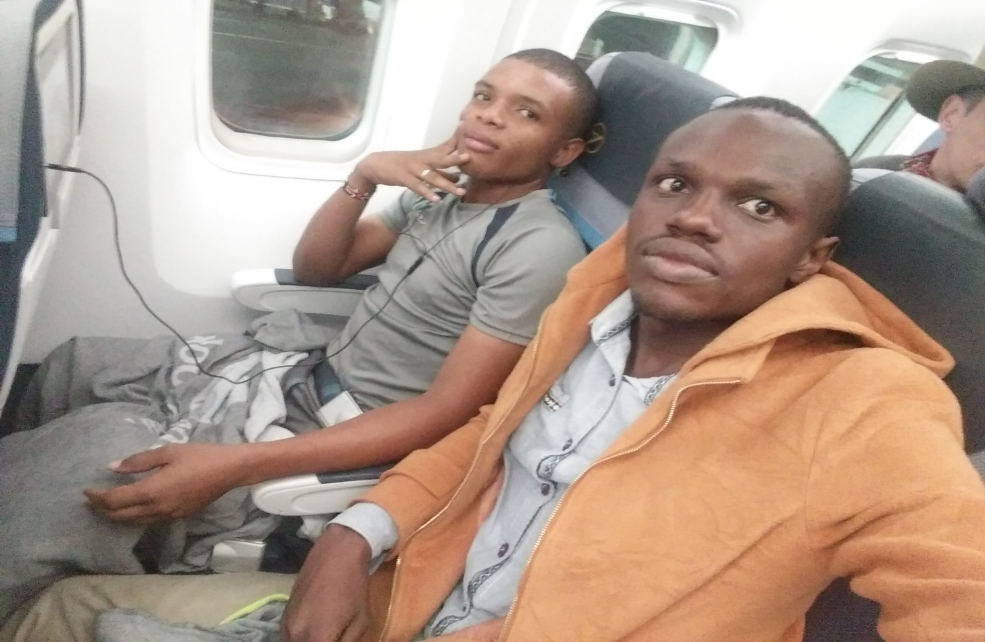

Arriving in Germany.
We arrived in Frankfurt airport in the wee hours of 18th March, 2019. It was around one degree and that was really cold for us. In the airport we couldn’t feel the coldness but when we finally got out of the airport it was unbearable. Simone Martin (a very nice and friendly lady came to pick us at the airport). She had seen our faces on WhatsApp so she recognized us immediately and came straight for a hug. I didn’t expect a hug from a stranger but hardly did I know that was like a German culture- hugs from everywhere. Another shock that hit me in the airport is how people would just kiss in the public, others even in front their parents, this never happens in Kenya. With Simone, we came out of the airport into the cold. We hurried to the train station and took a train to Karlsruhe. Simone made sure everything was settled. Took us to penny supermarket and bought us breakfast. She took us to prof. Closs’ master class and met the other students. Everyone was warm and welcoming. Later in the evening prof. Closs took us for a dinner together with Simone. We talked, laughed and had fan. It was great.
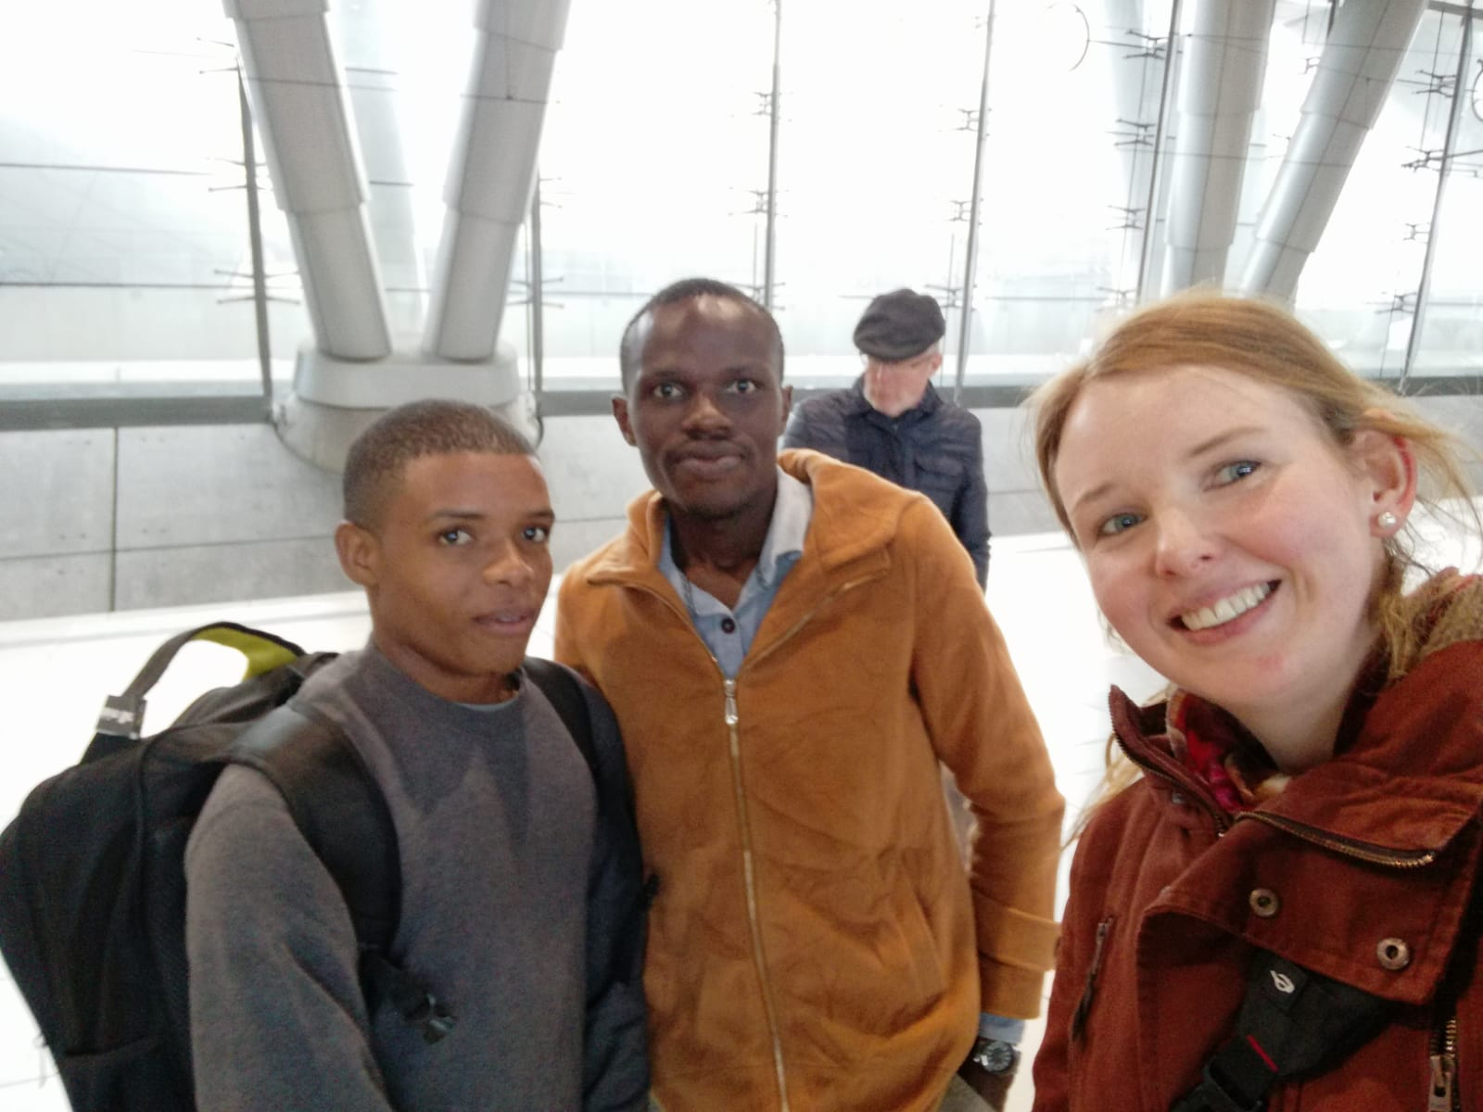
The second day we were invited for dinner by a group of students from the flat that I was to stay in from the 1st of April. We met at pasta pasta restaurant. We talked, had fan and ate some German food. After the meal it was decided we should go for a salsa dance at Besitos (a club in Karlsruhe) On the way to Besitos I fell on a bicycle and injured both my arms but at fast it didn’t look serious. We danced salsa until after mid night when we decided to go home. I massaged the arms with warm water and Vaseline jelly. Then I slept. Around 3 am in the morning the pain was so unbearable. So, I woke up Paul (my roommate that I came with me from Kenya), and we called an ambulance. I should admit the person in the emergency response was somehow rude, I guess it was because of the language difference. In the hospital first aid was done and an ex-ray. Then I was given some pain killers and told to go back during the day. A CT scan was done and it was decided that the damage was little, so a small bandage was placed on the arm and advised to go to a physician for more pain killers.

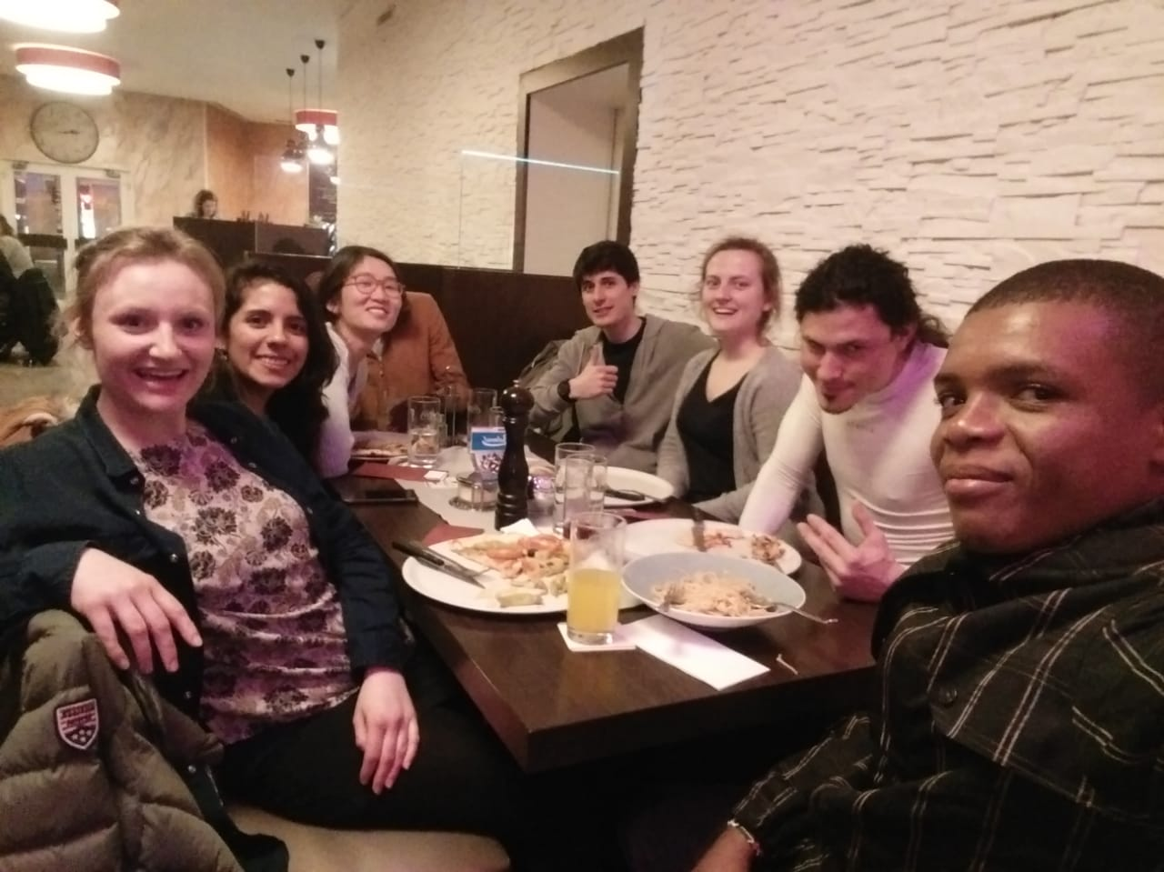
Having dinner at Pasta Pasta with new friends (from left) Virginia, Gabriella, Hoa, Paul, Sergio, Maya and Osmany.

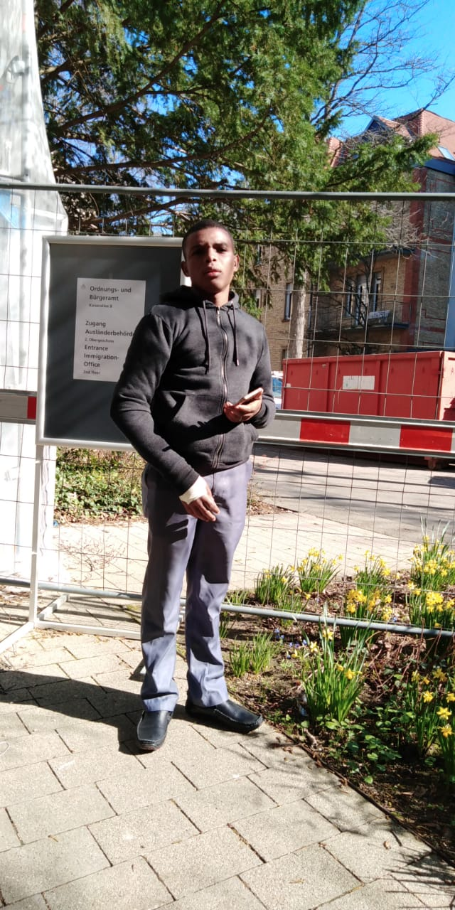 the injured arm.
The paper work.
Germany is a country with a lot of rules, especially compared with a country like Kenya. Everything has to be documented. Even moving from one house to another you have to do some paper work. So, we embarked on it with the help of Simone and Jacobi (my buddy) who took us to the city center after unsuccessfully looking for it in the morning. We did our registration with the city offices but we couldn’t finish because we hadn’t matriculation number to confirm we are students. So, we finished our registration at the university then went back for city registration. After registration we received vouchers worth 50 euro each and a lotto ticket for bicycles- we didn’t win.
Then we went to the KVV offices for the six-month free tram tickets. This was like a pass to visit almost every place the ticket could take us to. Which we did and enjoyed so much. We visited the following places;
Baden Baden.
On Sunday 21/04/2019 we went to Baden Baden with Paul at around 2pm. It is a nice place to be. Compared to Karlsruhe, it is very quiet, has siren, no trams around the place. People were not so busy but just relaxing in different places and others were sitting at the ice cream shop, so we also ate ice cream and then proceeded to the hills walking. We walked for around one hour to a certain village which was very deserted. There were no people walking around, the few people there just past us in their very old but well-maintained vehicles, going down to what looked like farms from up where we were. We could not go down there because we were afraid. So, we decided to go back to the station, past the ice cream shop and grabbed ice cream and went to the station and back to Karlsruhe. It was also a great experience.
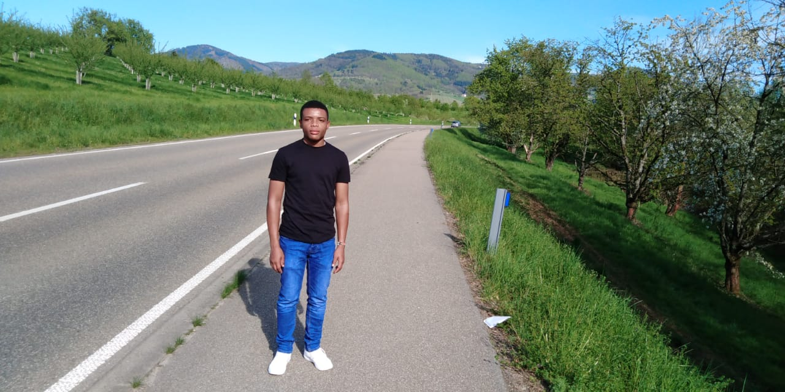
In Baden Baden

Heilbronn.
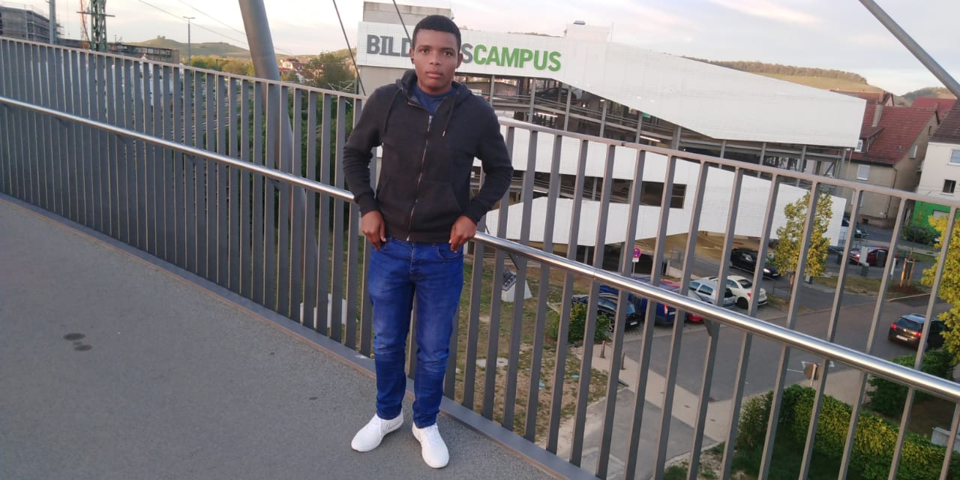
Then we visited Heilbronn town. It was unplanned trip and we just took the tram with Paul one evening when we were bored in Karlsruhe and off to Heilbronn. We spent the evening there. Visited the Bildung campus’ library. Then we walked in the town to the flower garden. We didn’t go to see the flowers. We hurried back to the station because it was already 7.30 pm and went back to Karlsruhe.

Bad Herranalb
We also visited Bad Herranalb. It is also a very small town with a lot of tourism activities. People from all over Germany were there enjoying the sun, others enjoying the art. Others enjoying tea and ice cream in the restaurants and ice cream shops respectively. Others were just enjoying a walk in the parks. We also walked in the parks, along the roads, enjoyed the art also and Paul also enjoyed ice cream, but I didn’t because I was fasting. The place seemed colder than Karlsruhe because it was at the base of the hills and in the middle of the forest. It is a nice place to visit. On the way in the tram you can enjoy the view of the forest, the trees, the nature, it is just awesome.

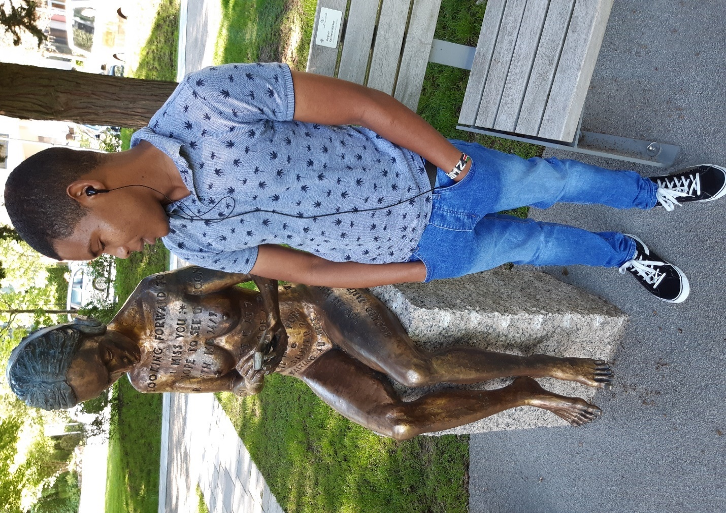
A piece of art in Bad Herranalb.

The finals.
Because I am a fan of football, on 26th of May I went to watch football. It was a final match of Baden cup tournament between KSC (which had been promoted to the second Bundesliga league for next season) and SV Waldhof. The KSC won by 5- 3 and were crowned the winners of the tournament. It was a great match and I enjoyed the whole of it. It was a very great experience especially watching it in a foreign country, seeing the supporters of both teams exchanging bitter words while singing praises for their home teams. The stress came after the match, because the police had blocked the roads especially back to KIT campus. We had to walk into the woods to HADIKO where I took a bus to the KIT tram station. It was hectic but worth it. I enjoyed the match.
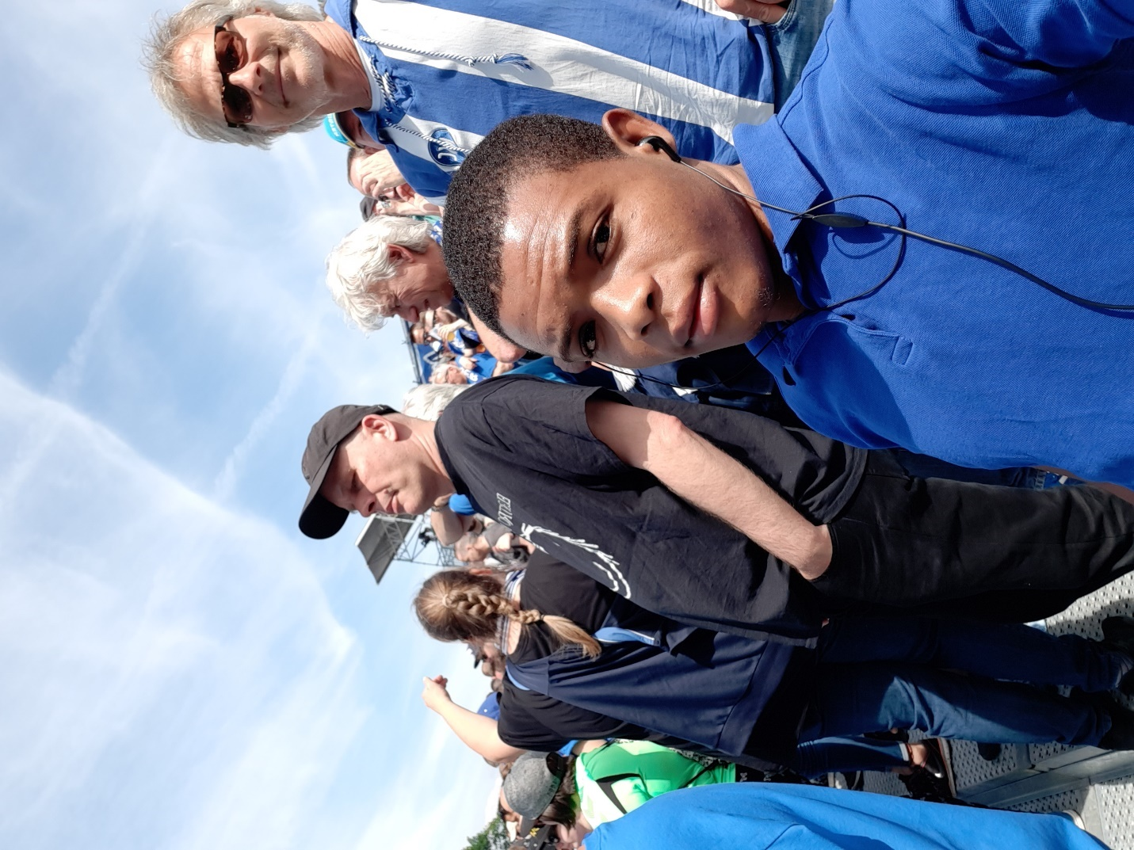
With other fans at the stadium.
The Cinemax.
I once, together with one of my flat mates went for a sneak preview at the Schauburg cinemax in Karlsruhe. We met with other friends and enjoyed the movie. I am planning on going to the Cinemax again at the ZKM for the release of another animation movie that I like, ‘The secret life of pets’, on 7th June.
The spring schools.
On 28th and 29th may we had spring school at the KMM faculty and it was a really nice experience. Three of the participants came from Pwani university to demonstrate a Swahili culture, especially the food. Another group came from Belgium and another one from Romania.
In the first day there was a presentation about leadership in the morning in which many students and others even from HSKA participated.
In the afternoon, there were two presentations; about veganism and the vegan culture and about Swahili and the Swahili culture;
A presentation was done about veganism. This drew a very big discussion between the presenter and the participants who were mostly master students. A lot was discussed, about the veganism belief, justification and then about the vegan food. It was really educational, I got learn that veganism is becoming popular in the west and even very many celebrities like Criss Pratt is a vegan. Well I knew nothing about veganism until after this presentation. Although many people are against it, personally I think it’s their life choice, but I also think if everyone decides to go vegan then the world will lack the which is there between human and nature which am sure it has a negative effect.
Then came the presentation about Kiswahili, Swahili culture and Swahili food by Dr. Rukia Harith. It was a great presentation and nothing much was discussed about it between the presenter and us listeners.
After the presentations around 3pm in the evening, we had to be split into three groups; one group was supposed to prepare Swahili food, the second one was to prepare a vegan food and the third group was to go for a tour round the city of Karlsruhe guided by an app developed by a group of students and our leader was Dominic- one of the students who developed the app. We started with Karl square just outside the faculty. In every station we were supposed to answer questions about it then the app would lead us to the next station. This was very educational, we got to learn about things which we used to see and think they there’s nothing serious about them; we didn’t know the stature had a lot than just a stature of the Karl on his horse. There is about nine horses and 32 faces of people. There’s also a number of fighters on the floor. We learnt about the coins minting house, about the orange house, the orange line passing at uropaplatz, the city library and its catalogue, the catholic church built in the early eighteenth century, the garden behind the orange house, and then we also got a chance to enter the museum and climbed up its tower. Great history about the museum that we learnt, with all the ancient artifacts in the museum.
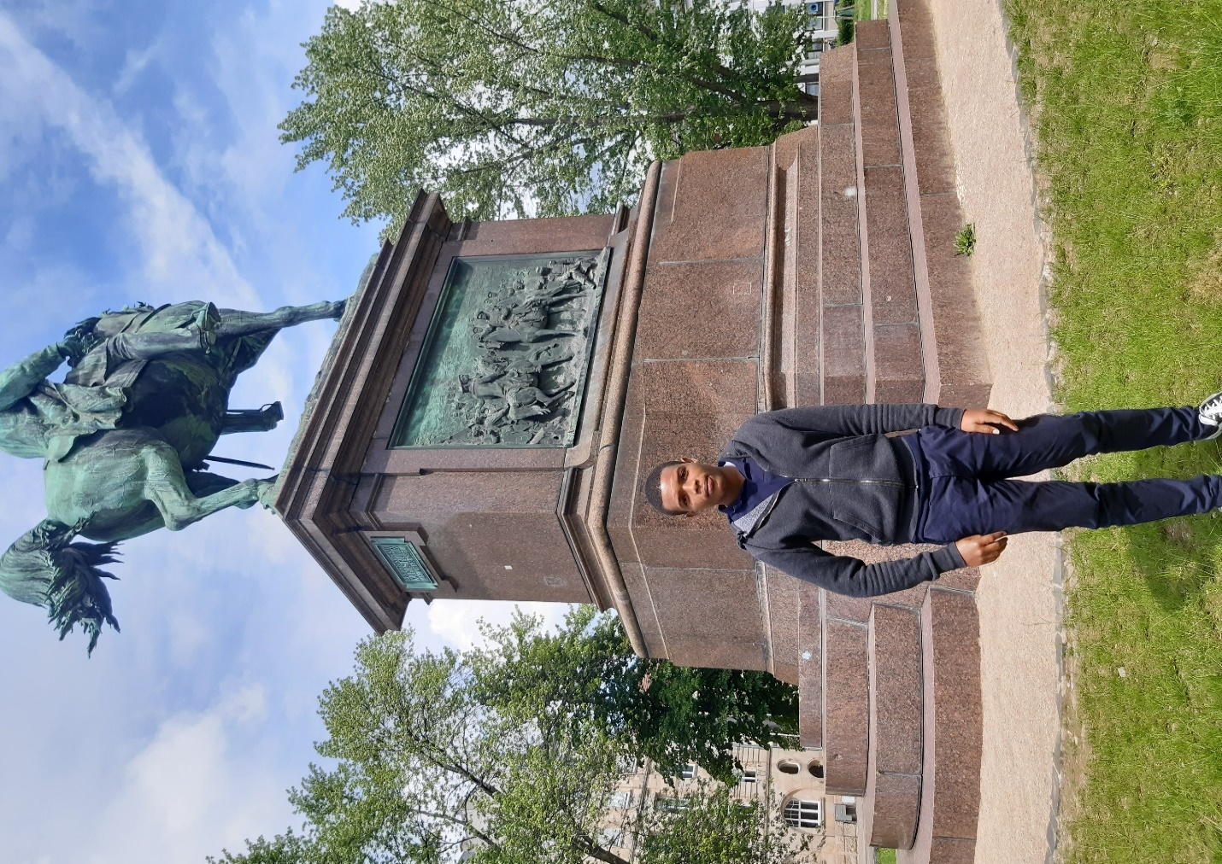
At the beginning of the town tour.
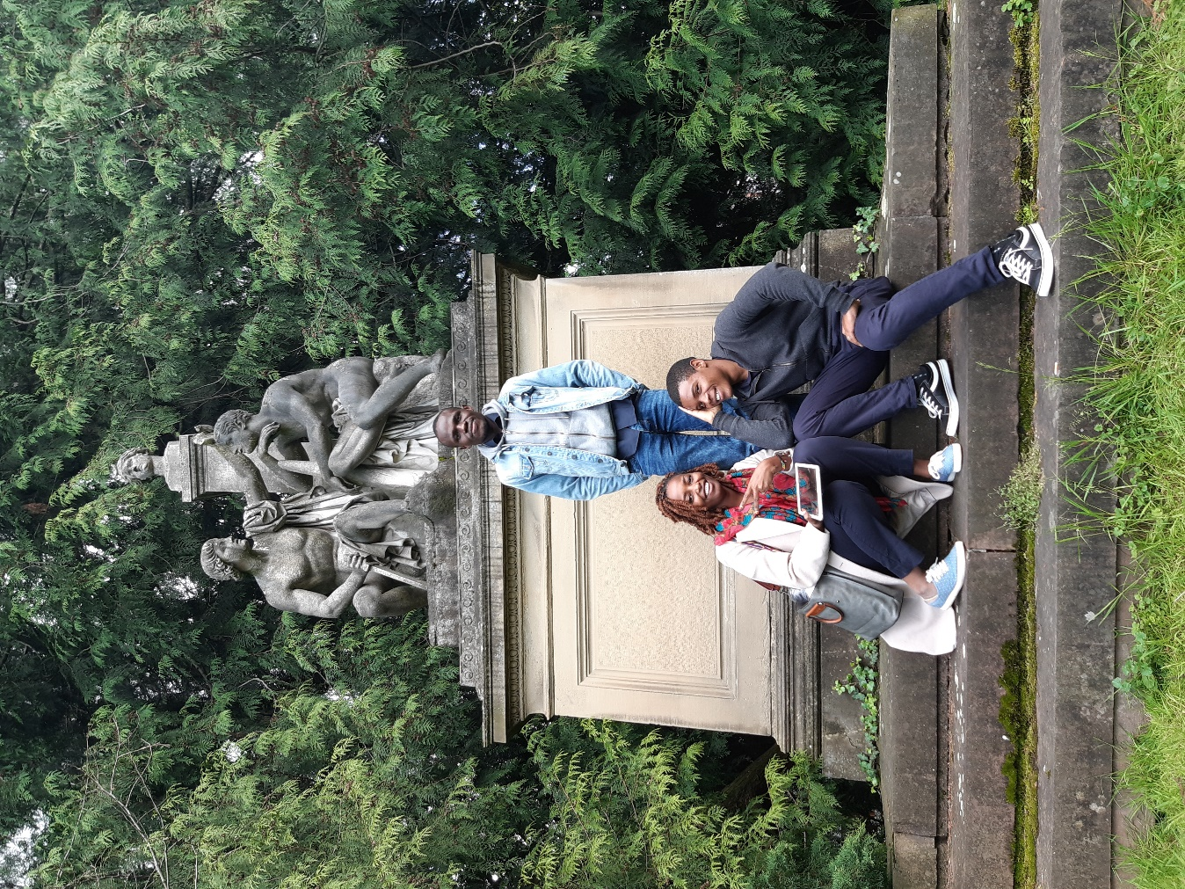
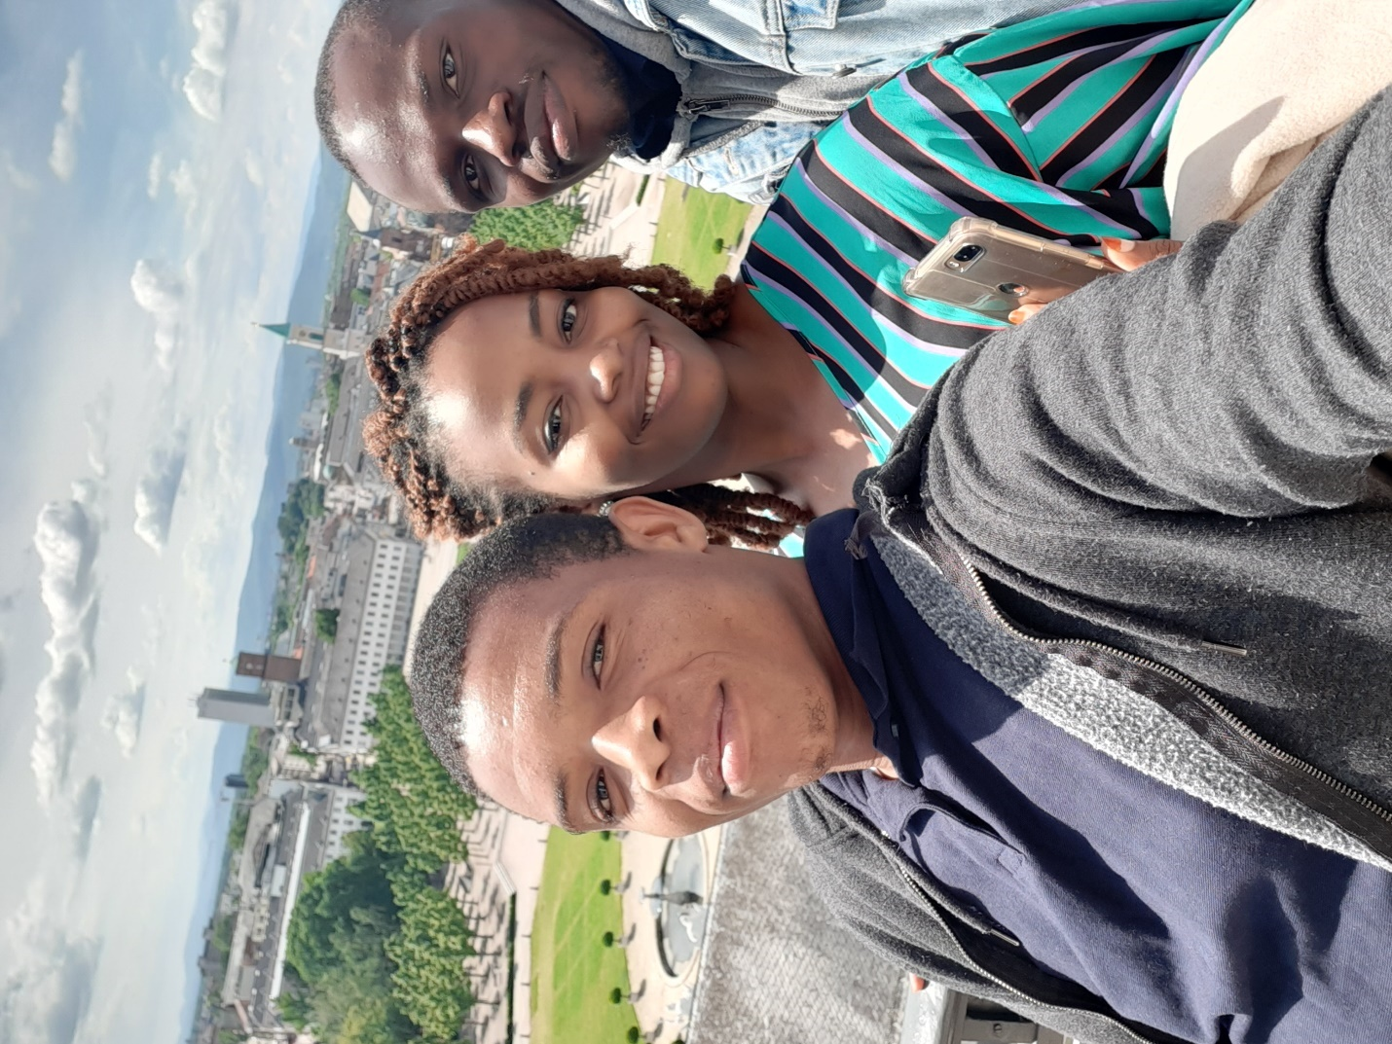
From up the tower.
The next day we listened to presentation from the different lectures that had attended the spring school. At lunch time, people ate the Swahili food and the vegan food that was prepared the previous day. In the afternoon, the master students (us) presented our projects and we received very positive comments.

The conferences.
On 15th and 16th, may 2019, we attended the SAP conference and it was a great experience. We were there with another master student (Evelyn) who also had developed an app that identifies different items in a toolbox.
Other things were also in display from different institutions and people.
We also attended most of the presentations and in the auditorium and participated in some of the discussions about technology.
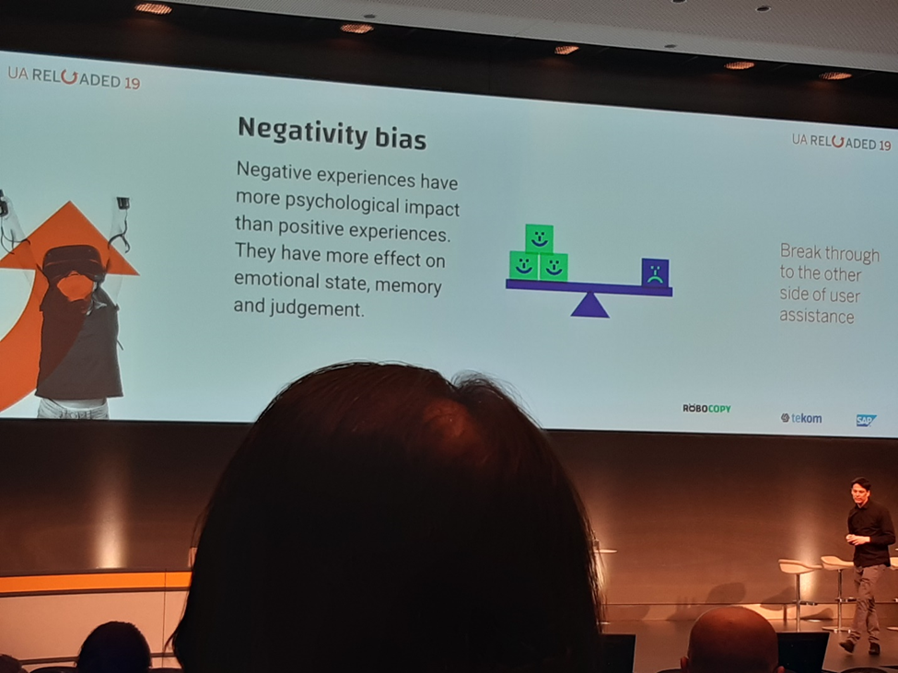
Swahili colloquium in Bayreuth.
From 31st May to 2nd June I was in Bayreuth for the 32nd Swahili colloquium. I went with one of my lectures who had come for the summer because she teaches Kiswahili and she also had a paper to present (Dr. Rukia). Here, I got a chance to interact with several professors and scholars of Kiswahili. I got a chance to listen to very many presentations and also took part in discussion in the questions and answer sessions. I also presented my master proposal and a poem by one of mabati-cornel prize winners who couldn’t attend the ceremony.
I also had a chance to interview with DW radio network about matters concerning the Kiswahili language. Also had another interview for YouTube. It was nice experience.
I also had a chance to meet my uncle, professor Rocha Chimerah; a professor of Kiswahili and African languages. It was great because we met outside the family setting, in a professional venue. He was also very delighted, very happy and very proud of me that he introduced me to all his friends.
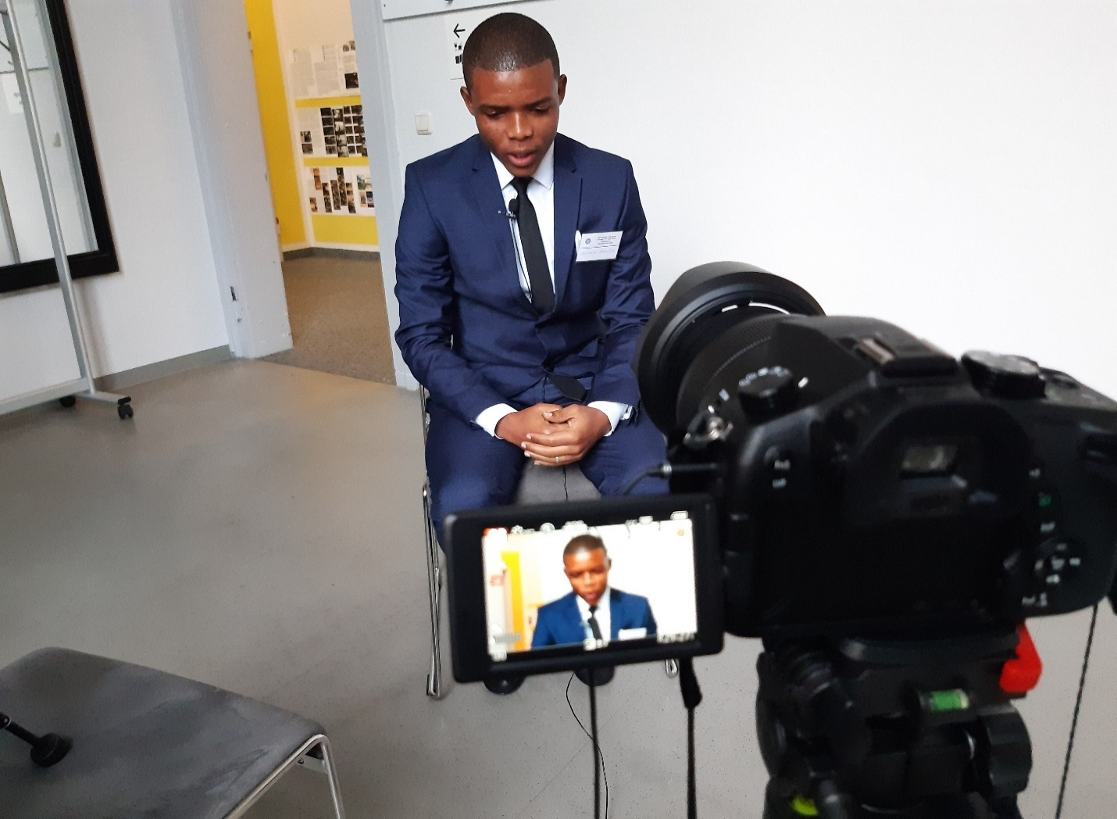Interview with DW.

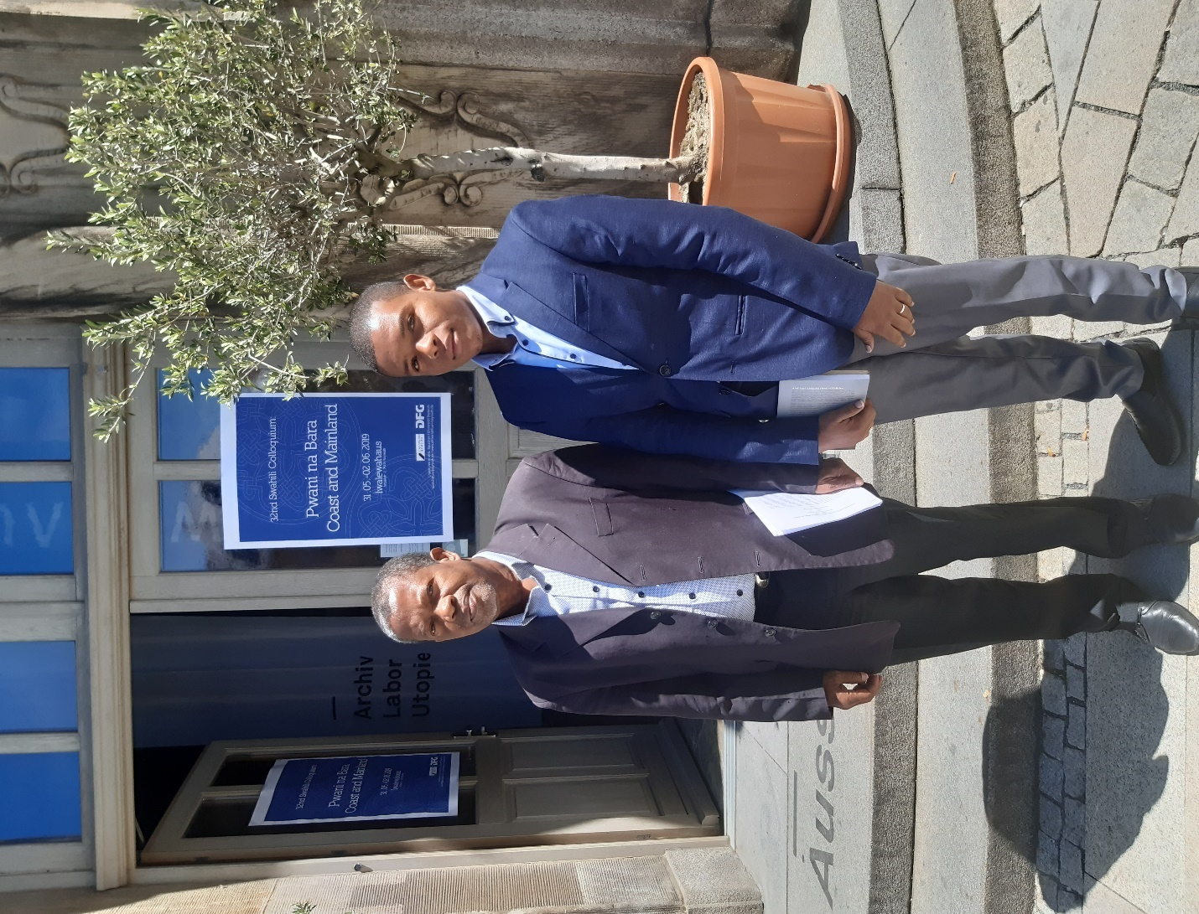
My uncle and I in Bayreuth.
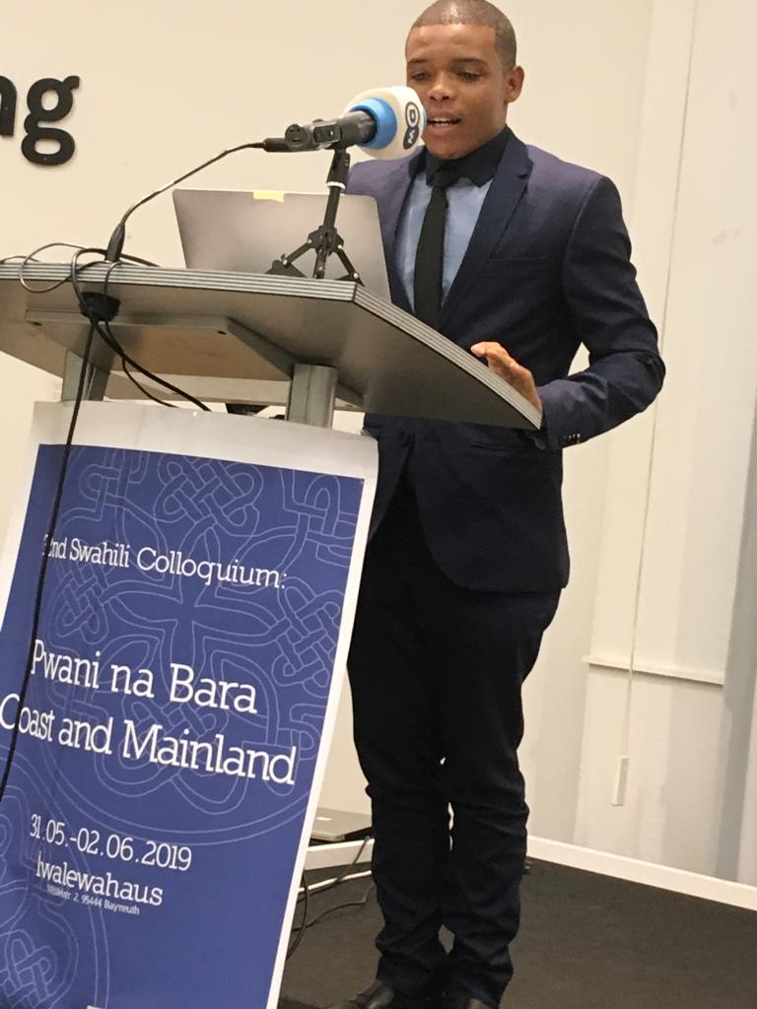
Studies.
After finishing all the registration of courses and at the city, we were set to begin attending classes. And I should admit in Germany a lot of emphasis is put on practical and group work. For example, one of the courses we visited was design thinking. The course started with us working in a group of two where our main task was to listen to the requirements of your patner and then make their ideal pocket wallet. It was great. After the task was over, we were into two groups and we were required to choose a topic then conduct an interview in the streets and the present the findings. We did this for the two weeks then presented our final report for grading. This is what happened for most of the courses. Presentations every other week. And it was a good learning experience.
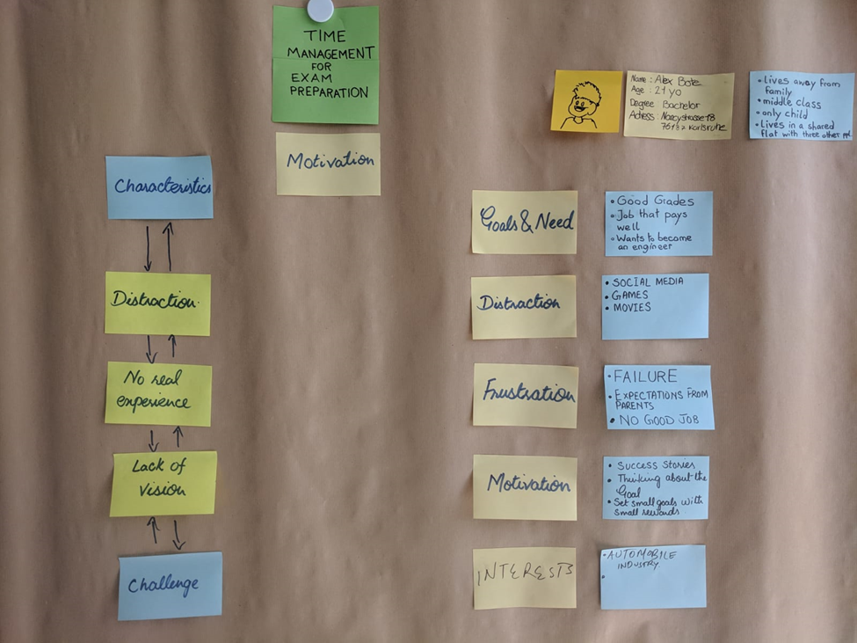Our task for design thinking course.
My personal experience
The culture.
As have said, the culture shock immediately hit me at the airport. Seeing unmarried people kissing in public, especially in front of their parents is something I didn’t expect, but it happened. Kissing is always taken as very intimate in Kenya, it can’t just happen in public, its bad manners, nut in Germany people can just kiss anywhere, in the parks, in the tram stations, while walking. And this is not even married people, just boyfriend and girlfriend. There’s a day I came across very young children like twelve years old trying to kiss goodbye at the tram station after, they were afraid so they had to do it quickly.
And then there is the issue of boyfriend and girlfriend. my conclusion is that you can’t talk with a German and finish a whole conversation without the word ‘my boyfriend’ or ‘girlfriend’ being mentioned. People are so open with their relationships. Most of the time the partners would visit each other and sleep over. This doesn’t happen openly in Kenya. Especially for a man to sleep at his girlfriend’s place, it would draw a lot of criticisms and mocking even from his peers.
These relationships moreover are very open and serious for the youth the concept of married doesn’t really appeal to them. Most of the guys that I had conversations with, especially the ladies were reluctant to it. They say what’s the importance of getting married and then divorce after some time. So, they prefer to just live together, have children when the time comes with no commitment of staying at all. This argument of course inappropriate especially in a religious standpoint. But that’s another thing, most youth that I talked to don’t really believe in God, or even if they do, they want nothing to do religion or churches. They argue that the church is used to hide and justify a lot of bad things that happen in the society, because of that they wouldn’t want to be a part of that society. In Kenya it’s the opposite of this, churches are mushrooming everywhere, and every Saturday and Sunday you would hear music and prayers all over the places.
This happens even to the Muslims. I met one in particular that confessed to be a Muslim but doesn’t really practice because he thinks he’ll just be fine as a human without having religion telling him what to do and how to live. It was weird to me. I think in the next generation religion will be even less popular.
The cigarettes.
German is the first place that have seen women and young girls smoking in public and it’s not a big issue. In Kenya smoking is only restricted to those men who are normally regarded to have ill manners. In Germany everyone who wants to smoke can just smoke in the public without the fear of being judged. And drinking alcohol is also a normal thing to everyone. Except pregnant women.
Class
The lasses in the university are not very strict. The student can decide to eat or drink while the lecturer is busy teaching and it’s a normal. This freedom is unfound in Kenya. In Kenya you are not supposed to even talk when the teacher is teaching in class.
The language barrier.
Language barrier was one of the biggest challenges especially when it came to paper work. Everything is written in German and we always had to have someone translating the text to us because you can’t translate all that text using the translating apps especially for a short time.
In the supermarkets also it was difficult to pick the right item. I remember one day Paul bought a shower gel instead of a body lotion. Well, it was a blessing in disguise because that is what we came to use as our shower because unfortunately bar soaps are not very common in Germany, even the famous Dettol.
The food
I can’t say I ate a lot of German food, because I didn’t. On the first day we went with Simone to a restaurant and I had Yufka for lunch. It was very good but again I hate spicy food, as well as salad. Yufka and falafel both have salad so I didn’t like it.
In the course of my time in Germany, I also tried some other German food in the student catering unit and I was always not comfortable eating them. Every meal has to be served with salad that I don’t like. So, I decided to prepare my own food and I mostly ate rice and pasta until when I discovered an African shop that is owned a Nigerian lady where we found maize flour and then I started enjoying our Kenyan ugali.
The German food is mainly bread served with salad. At home this salad is always mixed with wine which made me not to like it even more because wine is haram in Islam.
However, I think it’s a very healthy diet and honestly speaking I will learn to like salad and serve it with my meals back in Kenya.
Partying
I think partying and going out is also a part of the German culture. People have plans for almost every weekend and every public holiday. They enjoy going out and drinking alcohol. I think everyone drinks alcohol in Germany except those who are so religious (Muslims). I was invited several times for drinks and I didn’t fail to show up, and I was always about what drinks I take and I said Fanta. Everyone wanted me to try even if it was alcohol free alcohol, but I didn’t. Alcohol is served with almost every meal especially in the restaurants.
Every weekend, especially when it is sunny, people always find places to visit. Mostly if they are nit traveling then they are spending time in the park playing games, drinking and eating together. There is another a certain game that court my attention in particular- the three friends were playing football on opposite sides and if anyone misses the ball, he would fetch it and the others would drink till he gets back with ball. It was fan to play and watch.
We attended so parties of such kind especially in HADIKO where there’s a party almost every day on the rooftops. Students meet and talk, eat together, drink together and have conversations almost for the whole day. It’s a great way socializing and getting to know each other, their different cultures and backgrounds.
Service delivery.
Germany is a very organized country; I think the whole of Europe is compared to Africa. When we were signing the forms and about the details, we didn’t quit understand some of the things required in the papers until we got to Germany and why those details we required. Things like address of the street, number of the house we were living in Kenya, street name and number, area code, all these things didn’t make sense to us until we got to Germany.
All the houses are built in definite street and every street has a name, every house has a number, every house has a doorbell and speaker. These things in Kenya only exists in estates built certain companies like the one I lived in Mumias, I still remember it was number 99 but that was long time ago.
Because of this the letters are delivered at the doorsteps of the receiver’s house. A package is only returned to the post office when the receiver is not at home. In Kenya you have to go to the post office to collect your letters.
When I was injured and called the ambulance at night, they asked for the street and house number and after some minutes the ambulance was at door.
Water and electricity.
In Germany, in the two flats that I lived no one owned a basin or a plastic jerrican for water storage. The concept of water shortages is very uncommon for the people. The water and electricity are ever available. Not a single day there was a blackout or a water shortage. In Kenya we are used of such things and everyone owns jerricans to store water.
Transport.
The transport system is very organized. From the infrastructure, the facilities and everything. Very many trains in service for the long distances. In the cities like Karlsruhe, there are trams which are in service until late after midnight. And especially for Karlsruhe city, the trams that go for long distances outside Karlsruhe have WI-FI installed. The WI-FI is also available in all the public places, and I found out that this is specifically in Karlsruhe and perhaps other big cities but it was not the same case when I went to Bayreuth, there was no trams or WI-FI anywhere in the city, except the building in which the conference was held.
Ramadhan
After a month and two weeks of my stay in Germany came the Islamic holy month of Ramadhan. As a devoted Muslim, I was obliged to fast for thirty days consecutively. Despite the privilege accorded to a Muslim traveler not to fast, I decided not to miss on such a blessed month, so I decided to fast. It wasn’t so easy because in Kenya we are used to fast only for twelve hours, from 5am to 6.30pm because it is at the equator.
In Germany, because we were in the summer time, I started fasted when we were supposed to start fasting from 3.37 in the morning to 8.50pm in the evening. By the end of the holy month of Ramadhan, I was fasting from 3.00am to 9.23pm in the evening. Those were almost eighteen hours of fasting. I should admit it was very hard for me. But I did it and I’m very proud of myself because of it. The holy month of Ramadhan made me cut off most of my activities, especially the parties and the trips around the city. I stayed indoors and concentrated with my acts of worship and other responsibilities.

The cold.
When we arrived, we complained about the coldness of the place. Especially for who had spent most of my life in the coast it was really cold. Simone had to give me one of her jackets and then I bought another that I war with Simone’s, that’s when it got better for me. Summer delayed and it was cold until late May. Sometimes it could rain just unexpectedly for me because I didn’t pay attention to the weather forecast. In Germany especially during spring you should always consult the weather forecast because it could rain anytime.
I should admit I didn’t like being in heavy clothing all the time.

Racism
If I’m asked about racism in Germany, I would say it doesn’t exist, especially in Karlsruhe. I never experienced it, and if I experienced it was in a very minimal form;
Ta the Airbnb where we lived after arriving some German (who was very nice to us by the way) once asked if we were refugees from Africa. We laughed before telling him what we came to do in Germany. A part from that, nothing racially came from him, but personally I didn’t understand why he thought every black person should be a refugee from Africa. I understand there are black Germans, although most of them that we talked to told us they often have to meet that question and to them its frustrating even more because they were born and raised in Germany.
One day, after around five days in Germany we went to penny supermarket next to our house and went around in the supermarket with my bag on my back. When I went to the counter before I reached the counter, I guess one of the servants signaled the security officer and my bag had to be checked and frisked for any stolen goods. I thought it was normal until when we got out and met one of the white guys whom we didn’t even know laughing with disguise of what had happened and the he told “welcome to Germany”. There is when it hit me that the act was ill intended. When I went back to the supermarket with my bag, I went straight to the counter and out of caution asked them to keep my bad because that’s what the security guy told me, that all the bags should be left near the counter. This time the guy told me no one leaves the bag there, and when everyone who had a bag did shopping with their bags. Well, it was nothing serious, because I guess if you don’t feel secure with some around your business you should take precaution.
One day after injuring my arm thus I could not go out for the parties my colleague Paul went out with the other guys that we had dinner with to a certain club and some drunk person called him a monkey. He was drunk. And Paul was very angry and confronted the guy. Fortunately, the manager of the club intervened and threw the guy out, asked for forgiveness from Paul and even offered them free drinks.
The old
The family set up in Germany is very different from the family set in Kenya. In Germany people live independently. They have only one, two or three. When they grow old these children begin their lives somewhere else and they only go home during holidays if they live around Germany. This makes the old to be lonely, at least this is one of the findings of the other group in our creative thinking class. They interviewed the old and that’s what they say. In HADIKO there is a house for the elderly where they live because they don’t have relatives around to take care of them. In Kenya its very different especially where I come from. We still live in a community set up and everyone is taken care of very well. The old live with their grandchildren, or some relatives are sent to live with them to take care of them.
What I will curry home.
I always thought I am a very nice person because of my religion. Well, Islam advocates for service to humanity, and every Muslim should be humble, good especially to the orphans and the less fortune.
I Germany I met very nice people, especially the young ones who confess to not believing in God or any religion, but they are being nice because they feel that’s what humanity is all about. This opened my eyes and thought that people should not be defined by what they believe in, as long as they wish the better for whole of humanity. I think this mentality is the best weapon to counter racism with. Because after all we are all human beings, regardless of the color of our skin or texture of our hair.
If this is what is adapted by all the youth then racism will be a thing of the past. Unfortunately, this is common only to the youth who are educated and well disposed to the world.
I didn’t spend most of my time outdoors because at first, I was busy preparing my anthology of poems for the Mabati- Cornel competition which has its final date for submission in June 30th. The came the holy month of Ramadhan which restricted me even more and I only participated in the necessary events.
The project.
During the first and the second master lecture of prof. Closs course, we had to chose from the different topics available but Paul and I had to chose from the two topics that were to be implemented as part of the program. I chose to take part in the agriculture project with Julien and Nero. It had to be implemented in DITA the final copy to be presented to the concerned people in the project. We did research presented the results in several sprints that we had in class.

Conclusion.
My stay in Germany was a very good experience to me. It’s something that I really had to experience although I didn’t know. I always wanted to live outside Kenya because of very many reasons, from the infrastructure, service delivery, the bad politics. Right now, I feel like Kenya needs people like who have been outside the country and see things are being done by others and change the situation in Kenya, if change is impossible at the moment then at least educate the masses on their rights and everything. At least to set the ball rolling. I think people like us are the epitome of change in our societies, something I am really eager see being achieved.

