My Experiences in Germany

Paul Mumelo
02/06/2019

Prologue

On Monday December 3, 2018 at 3PM or thereabout, I received a call from a strange number. I ignored it at first, because I was busy overseeing some work at the firm, and it’s not also in my element to pick calls from strange numbers. Amid hesitation, I decided to call back, only to be greeted by a lady’s voice. She introduced herself as Edith Miano, and she went ahead to inform me that my name had been proposed for a 3-month student exchange in Germany. She asked whether I would be interested in being part of the project. Of course I said YES, but I just wanted to buy time because I wasn’t really sure whether I wanted to go. At the back of my mind, I reminded myself that there was no way I would manage spending 3 months away from my friends and loved ones, and the usual comforts of Kilifi. I was also apprehensive about travelling to strange-land with Abdallah, someone whom I had never interacted with previously. It only took the intervention of my family members, who told me that the experience would be great learning opportunity and an eye-opener, for me to finally make up my mind…
Preparing for the exchange was quite stressful considering the fact the invitation came at a time when I was changing some personal details in all my official government documents. At some point, I even thought of quitting altogether because Edith kept pressurizing me to get everything together before the stipulated deadline. As a result, my visa arrived just ten days before the intended departure date. I even missed out on the opportunity to meet up with Prof. Closs when she visited Kenya in early March, 2018.

Leaving the Motherland

“To new beginnings,” I whispered to myself on that hot Sunday afternoon in mid-March. I then said my goodbyes to my loved ones as I departed Kilifi for Mombasa. I still remember the bitter-sweet feeling as I boarded the plane. I felt excited that I was going to Europe, where nobody knew who I was and where society didn’t really care who I was as long as I did my part and attended to all my academic engagements. On the other hand, I felt scared and sad. Sad that I was leaving everything and everyone behind and probably won’t see them for a while and scared because I was stepping into the unknown, away from the motherland. My greatest fear was adjusting to a new environment, making new friends, learning a new language, and getting used to a new cuisine. But I comforted myself with the thought that every day is unknown for us and that adulthood is all about taking a leap of faith and hoping everything will work out.
I barely recall anything about the 9-hour flight to Frankfurt. But when I finally landed, I must admit that it felt amazing, although too cold for my liking. From the airport to the amazing architectural jungle I just stepped into…. All I could think was “Damn”. I still get amazed to this very day about the beautiful majestic Gothic-era buildings they have and just how technologically advanced they are. Don’t even get me started on the cars people drive… I still get goosebumps from the purr of some cars this side of the world. The legendary German efficiency at play.
We were picked at the airport by Miss. Simone Martin, Prof. Sissi’s assistant at the time. She’s arguably the nicest person I met in Germany. From the onset, she explained everything that we needed to know about the German culture and way of life. Her bubbly demeanor went a long way in allaying some of the myths and misconceptions that I had about German people. It’s Simone who came with us from Frankfurt to Karlsruhe, and helped us check into our Airbnb accommodation. She event went ahead to buy us breakfast at Penny. Such a kind soul.

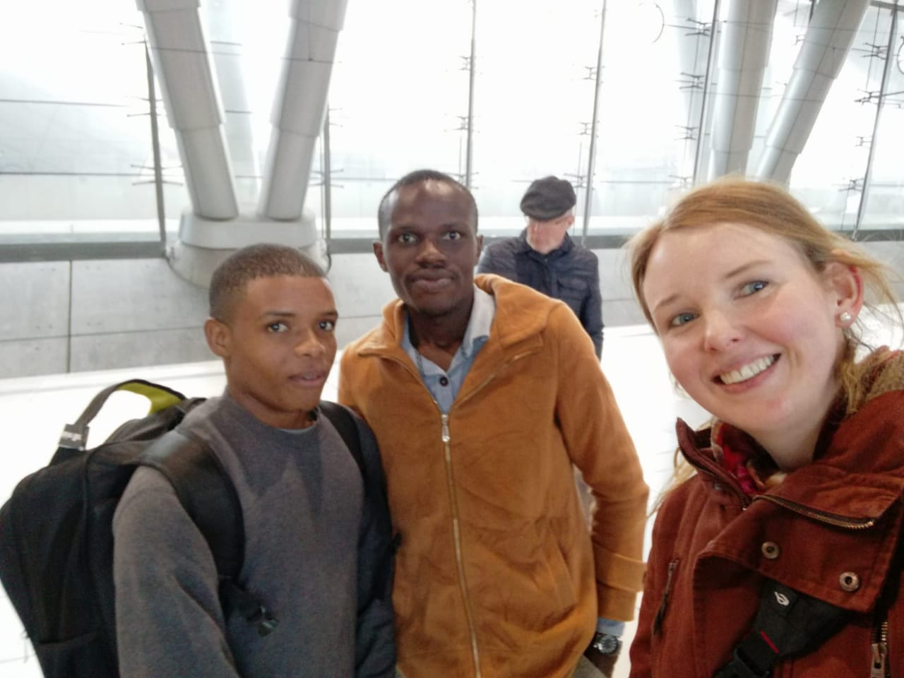
Abbildung 1: Frankfurt Train Station with Simone moments after she picked us.

Settling In

Our first accommodation in Karlsruhe was at Augustastraße 1, an old brown building with creaky stairs. However, it was quite snugly and also had a janitor who did most of the cleaning work (my dislike for domestic chores is well-documented). We were assigned a small 4X4-meter room with two beds. It felt weird sharing a room with someone else because the last time that happened was probably when I was in boarding school. The other appealing things about that small room is that it had an office desk and a chair where one could work from. On the downside. However, the heater was malfunctioned, so we had to put up with some really cold weather. Moreover, we were surprised to learn that our three-way plugs couldn’t fit into German two-way wall sockets. Fortunately, Simone came to our rescue and took us to Saturn to buy adapters.
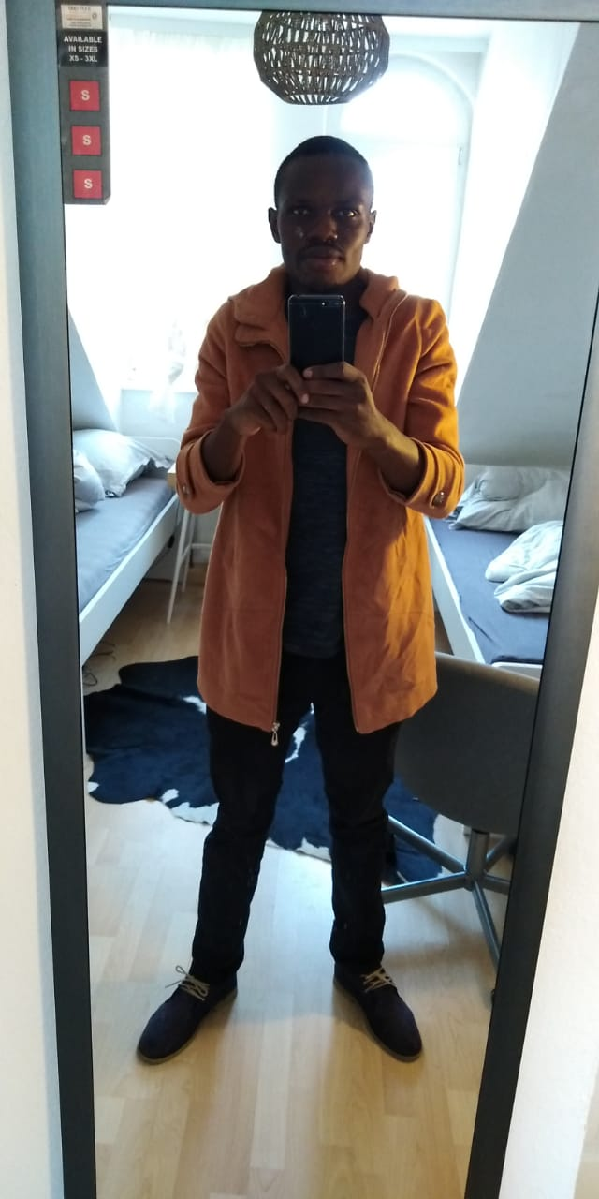
Abbildung 2: Our First Accommodation. The small beds can be seen in the background
The excitement that comes with being in a new country couldn’t allow me to rest. We spent most of the day talking about our fears and what the next three months had in store for us. The afternoon of our arrival day, we visited the IMM faculty for the first time. Personally, I was amazed by the level of organization and tech advancement in the lecture room. Coming from a university where students need to buy their own PCs, I got blown away by the fact that here, each student has access to a PC in class, something that makes learning even easier. Prof. Closs introduced us to the rest of the class, and even helped us choose project groups that we would be part of for the rest of the semester.
Before coming to Germany, we had been assigned buddies, whose role was to show us around town and help us acclimatize ourselves with the surroundings. My buddy was a chap known as Eshwar. He was away when I arrived, so I never got the chance to meet up with him on my first day (I haven’t to this day). As a result, we had to make do with Abdallah’s buddy, Johannes. He was quite helpful, and guided us on everything that we needed to do. He helped us find our way around campus besides registering for courses. He’s also the one who took us to the city office to get our semester train tickets.
I must admit that settling here was quite difficult, at least for me. Many times, I would stay up late into the night wondering whether I had made a good decision to come here. I’m naturally introverted, so making friends was hard for me. I met most of the friends that I’ve made here through Abdallah. With their help, I begun immersing myself in Karlsruhe’s social life like any 25-year old would do.

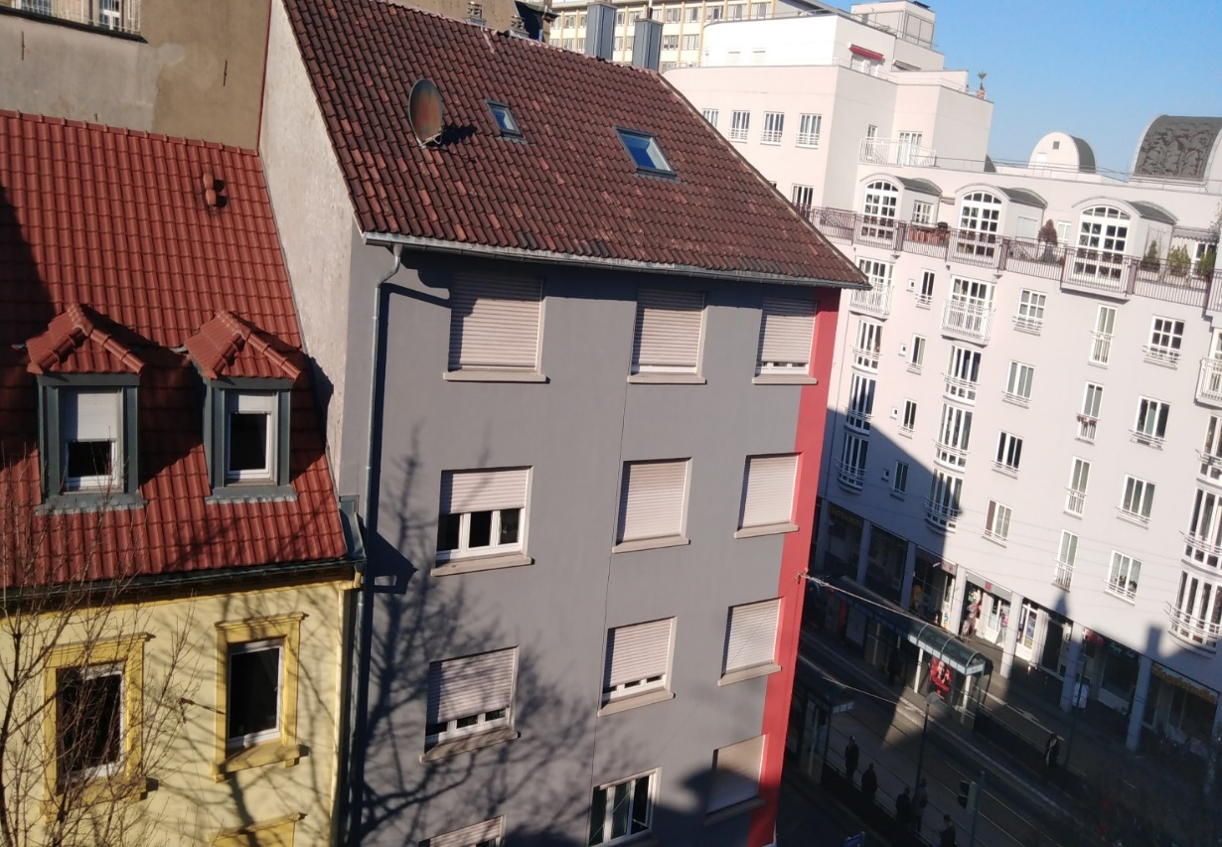
Abbildung 3: Mathystraße Tram Station, Photograph taken from our 4th Floor Window

Myths and Misconceptions About Germany

Earlier, I mentioned something pertaining to the myths and misconceptions that I had towards Germany and its people. These myths mainly arose from the conversations that I held with friends and colleagues who had travelled to Germany before me and experienced the culture. Being here for quite a while has gone a long way in helping me debunk those myths and misconceptions. Here are some of them.

Germans Are Unfriendly

Arguably, this is the commonest misconception that I heard from almost anyone whom I consulted about Germany. Most of them told me that Germans are generally unfriendly, and that they rarely smile. One even went ahead to tell me that I shouldn’t even bother saying hi to people that I bump along corridors or on the streets because they will either scowl at me, ignore my greetings, or both. From the moment I landed, I didn’t expect anyone to be nice or friendly to me. I also intentionally decided to keep to myself, and unless someone smiled or said hi first, I always kept to myself. But, that was until I noticed that Germans are not as unfriendly as I initially thought. Yes, I’ve met a couple of unfriendly people on the streets and at the placed that I’ve lived, but surprisingly, most of them were not even Germans.
Over the past two months, I’ve come to observe that Germans can be quite helpful to other people. Whenever I needed help, I would always throw in a couple of German words to put my helper at ease. I remember an incident when I was still new here, and I fell asleep on a night tram while on my way from hospital. I woke up at Tullastrabe, the city train terminus at around 1AM. Luckily, the tram driver had not yet left the terminus, and she helped me find my way home. That’s one of the most profound acts of kindness that I experienced in my life. Therefore, I can openly proclaim that Germans are not unfriendly.

The Language is Difficult, and You’ll Struggle With It

Since childhood, I had always wanted to visit Germany, but not stay for a significant period as I have. I simply dreamt of coming over to visit the factory where Mercedes Benzes are produced. I was always intrigued by the Three Stars. As a result, I was never interested in the German language, even though it was offered as an optional subject in my high school. When my application for the BWS scholarship got accepted, I kind of regretted not taking Germany back in high school. Before coming over, Edith would always encourage us to practice basic German. From the word go, I found the language to be simply difficult. One of the courses that we were required to take while here was German language.
Arguably, that was my most difficult course here, because the Professor taught German using German. Actually, most of the German I know was learnt on the streets rather than in that classroom. I dreaded Tuesday afternoons because that’s when the German language classes were scheduled. For some weird reason, the professor always picked on me to answer questions. I would sometimes mumble and tell her outright that I have no answer to whatever she’s asking. If it was up to me, I would recommend that A11 level students be taught informal German rather than the formal German. The latter comes in handy especially to someone who is visiting the country for the first time. Generally, German is as difficult as Algebra but the few words that I picked along helped me find my way around here, especially in informal places such as stores and bars.

The Culture Shock Will Make You Wish You Never Travelled

Almost everyone told me that within the first few days of landing in Germany, the culture shock that I will have experienced will make me wish I never came here in the first place. It’s an undeniable fact that Germany is wholly different from Kenya. Be it the country’s economic status, culture, weather, and way of life, everything is just different. When I stepped out of the airport in Frankfurt, I realized that I was in a whole new world. Everything was just happening too fast compared to the laid-back state of affairs back in Kilifi.
The weather was also awfully cold, cars were driven on the right side of the road, and I couldn’t even use my phone or charge my laptop because the electric sockets were different from what we were accustomed to. That was culture shock at first hand.
Culture shock can derive you a sense of belonging to the country that you are visiting. It makes you miss your home, and wish you were with your loved ones. I came to realize that the worst part about being away from home is not even about being mistreated, but being trapped in your own mind and finding everything totally new and strange to you. In the end, you feel lonely even after you make a couple of friends. In my case, I missed everything and everyone back in Kenya, including things and people that I don’t like. Be it the cool ocean breeze that hits you as you drive into Kilifi, or the musty smell of garbage on the streets, I missed it all.
So many nights, I stayed up in bed late wishing that I was back home, especially when I why eyes got swollen and the doctors couldn’t really find out what was wrong with me. I consider myself a sentimental person, and that made it even worse because I was always trying hard not to lose touch with people that I care about back home. During the first couple of weeks, it started out great. I was always on video call every evening. People always took time to find out how I was doing and all that. But as weeks passed by, I noticed that they were slowly drifting away. I could feel the distance taking toll even on my own relationship.
Most times, the communication breakdown hurt because it left me feeling all alone and that back home, people were moving on with their lives without involving me in their daily decisions like it happens when I’m there. What kept me insane was the fact that I couldn’t blame them. I always reminded myself that I’m the one who decided to take the chance and come to Germany. With time, I have come to embrace the German culture and ideals, even though some of them are in contrast to what I believe in. for instance, the incorporation of the LGBTQ culture in the German society was a little strange to me. However, I learnt to embrace everyone because after all, we are all human. I still struggle a little, but I guess it gets better in time.
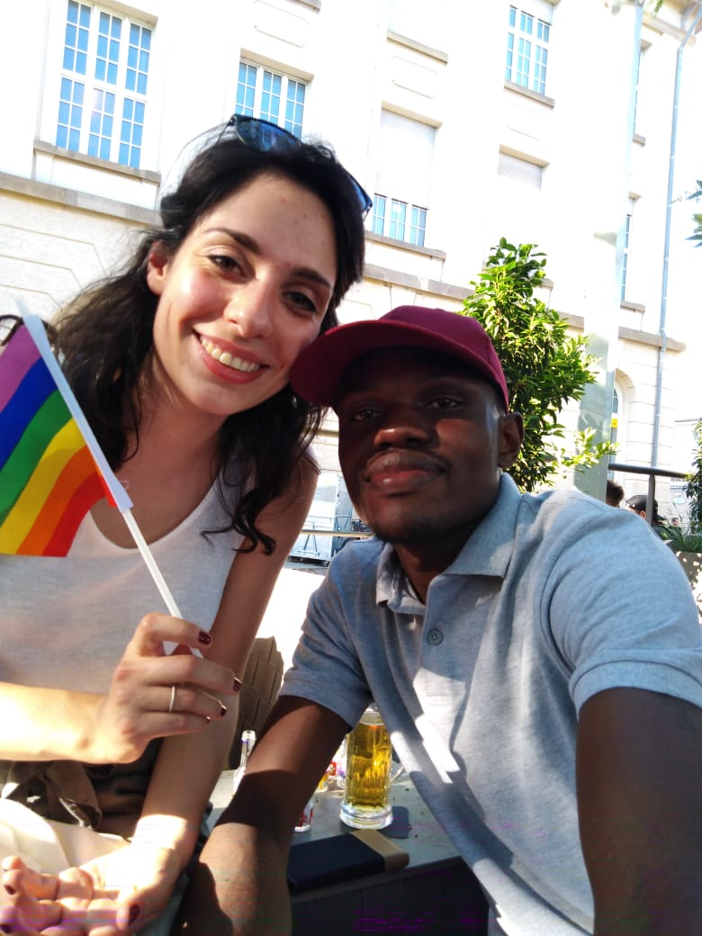
Abbildung 4: Attending the Christopher Day parade with Valeria D'Ambrosio

One thing that I’ve learnt in the past few weeks is that change is a difficult and exhilarating thing to go through. Thanks to that, I’ve been able to manage the culture shock even better. I’m now in a better position to survive anywhere on my own. I can now cook a proper meal, do my own laundry, and even live with people from different backgrounds and still accept who they are. Most importantly, the culture shock that I experienced has helped me to come to terms with who I am and what it means to strive for happiness even in the bleakest of circumstances.

Dealing with the Weather

It feels weird whenever someone mentions that I was in Germany for the summer semester. I can literally count with my hands the number of days that we experienced “perfect” summer conditions. One of the things that I dreaded about coming to Germany was the weather. In Kilifi, we experience warm weather throughout the year. My home village in Western Kenya is relatively cold, but even so, it isn’t as cold as Germany. When I came from Kenya, I thought I had carried a heavy jacket, but that was until we landed in Frankfurt. The weather was just incredibly cold. What felt even stranger was someone telling me that it was warm by German standards. I don’t think I can ever be able to get used to the unpredictable weather in Germany, though I can live with it.
As I write this, it’s quite and windy cold outside. I can also see rain droplets on the window. Quite surprising considering the fact that yesterday, the day temperatures exceeded 28 degrees. Our first accommodation had this faulty heater, which for some weird reason, always broke down or functioned below its capacity on the coldest days. To optimize on the little heat that it was producing, I pushed my bed as close as possible to the wall. In doing so, I would sleep with my head literally next to the fan. In addition, we always the windows closed so as to conserve as much heat as possible.
At Klosterweg 28, things were a little better because the heater was functional. Nonetheless, the room was a little too large and sparsely furnished, so it always felt cold. Everyone knows how it feels like to stay in huge house that almost has nothing inside except a bed and a desk. It will always feel cold in there. Fortunately, Prof. Sissi gave me a sleeping bag, and that made things better for me. At first, it felt weird, but I got used to it. Finally, I could enjoy warm nights in Germany.

The Food and Beer

In the course of my stay in Germany, I’ve learnt a lot as far as cooking is concerned. Before I came here, I couldn’t cook a proper meal that well. In Kenya, I had this little unwritten agreement with my girlfriend whereby she always did the actual cooking while I ran did odd jobs in the kitchen such as slicing tomatoes. Whenever she wasn’t there, I always survived on food take-outs, and never saw the need for me to polish my culinary skills.
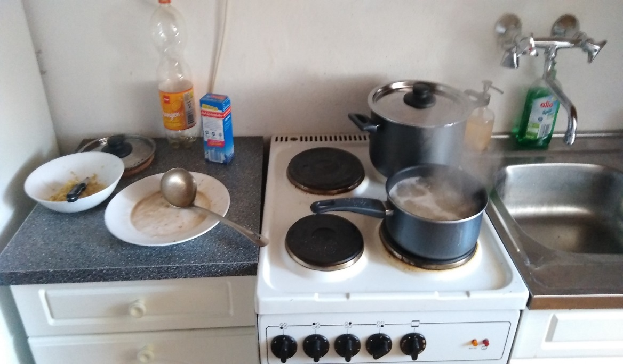
Abbildung 5: Preparing My first Meal in Karlsuhe. Pasta and Beef
In Germany, I was literally thrown into the deep end as far as cooking is concerned. I had two options, to either learn how to cook, or buy expensive meals at restaurants. Food here is costly, and therefore, it’s quite expensive to survive on take-outs. So, I was forced to learn not just how to cook, but also where to buy fresh groceries and other foodstuff at affordable prices. Fortunately, Simone had recommended to us places where we could buy foodstuff at affordable prices. Whenever I had a craving for a specific meal, I would do a video call to my sister or missus, and they would direct me on what to do. Thanks to them, I can confidently proclaim that I’m now an exemplary cook. I still have a lot to learn though because I cannot prepare more complicated Kenyan meals like Biriani and Pilau, but I have that in my bucket list. 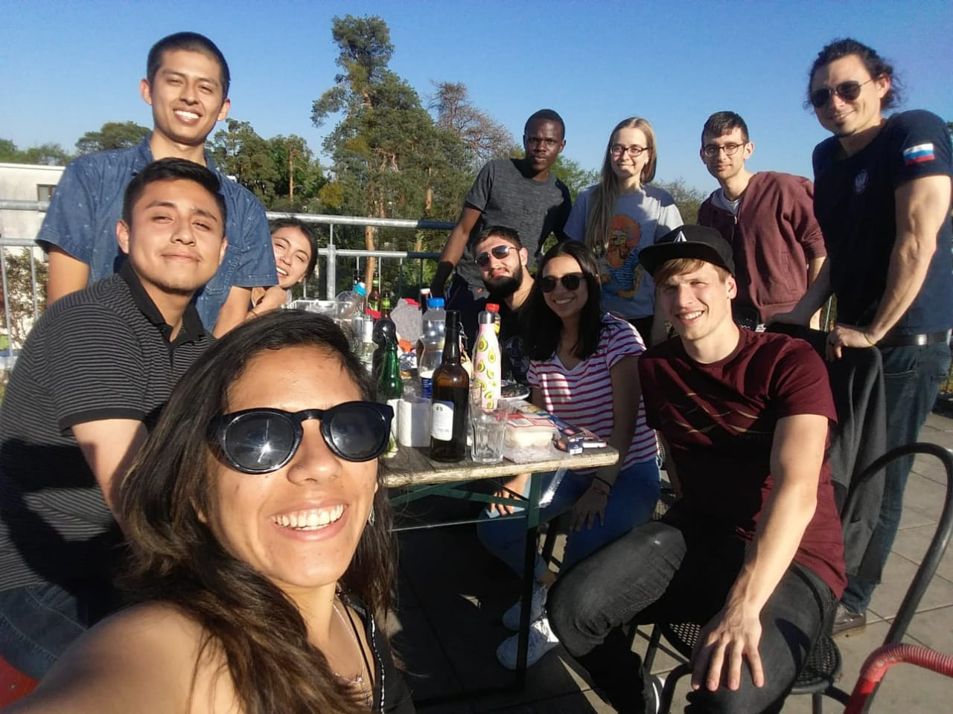
Abbildung 6: Barbecue with friends at Hadiko rooftop

At Hadiko, there is this years-old tradition whereby a new resident is supposed to prepare a meal from his/her home country for the rest of the floor. Two months later, I’m yet to do that. I bluntly told the floor representative that I’m not that good when it comes to kitchen matters. But these guys have been awesome, and they all contributed in one way or another to making me feel comfortable and welcome here (one of the things that I love about Hadiko is that it’s a multi-national residence where everyone feels at home). Before my stay here ends, I’ll definitely make them some ugali-nyama-sukumawiki.
Talking about sukumawiki reminds me how hard it is to find fresh food here. Almost everything is frozen. People here only grow crops on their gardens in summer, and therefore, you will hardly find fresh vegetables anywhere. In Kenya, especially my home village, things are quite different because we get everything from our farms.
I never saw my mum going to a grocery store to buy tomatoes, vegetables, bananas or even chicken because all that was on the farm. One of the things that I miss about Kilifi is fresh fish from the ocean. Here, fish is quite expensive. A floormate recently recommended Aldi as the best place to buy fish at an affordable price, but I still find it to be bland. However, the apples and strawberries here are quite tasty. I wasn’t a big fan of apples and strawberries, but that has since changed. I always have them in stock.
Anyone reading this is probably wondering why I haven’t mentioned German foods so far. You’d be surprised to learn that since I came here, I haven’t eaten authentic German food even once. You can’t blame me though. Our welcoming dinner was held at a Turkish restaurant, and we had pizza, which I know doesn’t originate from Germany.
Whenever we had a meal with Prof. Sissi or any of our friends, we always met at Italian restaurants. A classmate in the master course also intimated to me that German food isn’t that great. As a result, I’ve never bothered to have any of it. I’ll probably do that one day in future, but as for now, I’m at home with either home-cooked African meals or Italian food.
I can authoritatively state that Germany is a drinking nation. Regardless of what time of the day it is, you will always find someone having a beer in a street corner or on the tram. Among Africans, Kenyans have this reputation of being heavy drinkers, but I think Germans beat us hands-down on that department. I’ve had the opportunity to sample several German beer brands, and I could say they are quite smooth.
If you are a beer lover, you’ll understand what I mean. I particularly loved Radler, Bittburger, and Paulaner (because the name is almost similar to mine). Beer prices are also incredibly low, especially in supermarkets and perhaps that explains why people are always drinking.
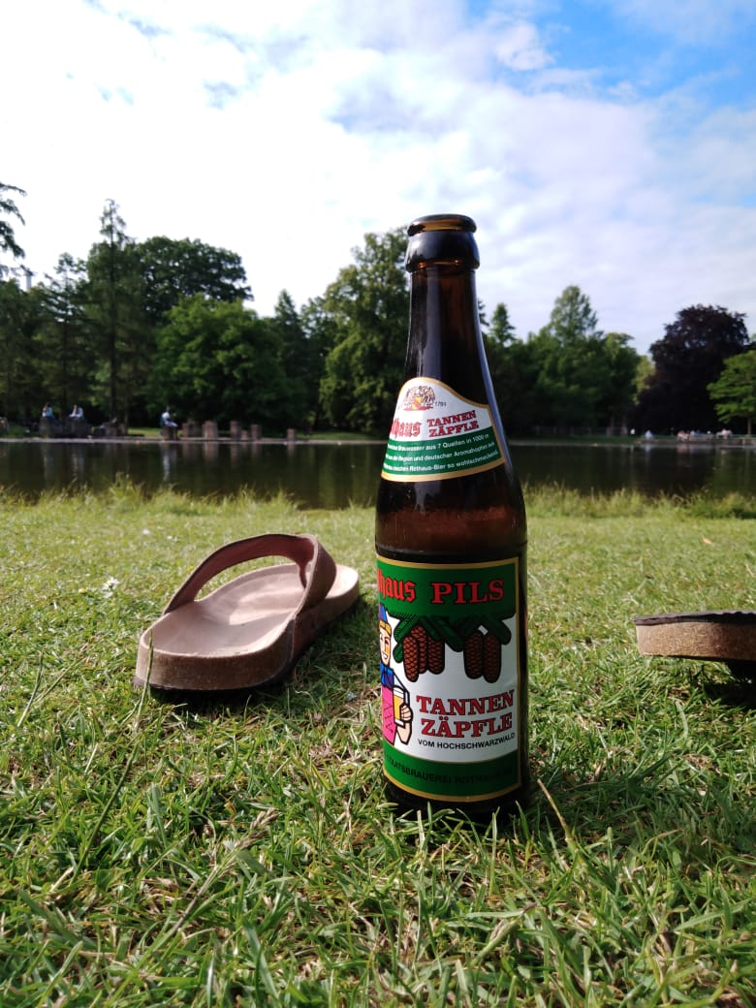
Abbildung 7: Cold Beer at Schloss Park on Good Friday

The Good and the Bad About Germany

In the course of my stay, I have had good experiences as well as bad ones that made me miss being home. Fortunately, the good experiences outweigh the bad ones by far, and they also offer great learning points.

The Good Experiences

a) Effective Public Service Delivery

From a young age, I’ve always known about the legendary German efficiency. Nonetheless, I only got to experience that while living here. I’m just amazed by the manner in which things are done. Services are provided to citizens as they should. In my interaction with Germans, a couple of them complained that the government isn’t doing enough, but I always told them that they are lucky because back home, it’s almost as if the government does nothing. I never experienced a power blackout, poor internet connection, or lack of water in the taps. I have never seen heaps of garbage on the streets or unending traffic jams. To me, these are hallmarks of effective public service delivery.
The transport infrastructure is superb. To this day, I’m still awed by the tram network in particular. Most times, I find myself reading about trams and how Karlsruhe managed to become a model city as far as its tram network is concerned. Whenever I felt lonely sometimes, I would find a nice book from a bookstore, get on a tram to Heilbronn or other far outposts, and simply indulge myself while taking in the countryside. I found it therapeutic, and it also gave me the opportunity to literally visit nearly all the major cities and towns in the state. I wish our leaders can borrow leaf from what happens here.

b) Availability of Learning Resources

Due to the abundance of endowment funds as well as adequate government funding, most universities here are well-equipped. Students have all the resources that they need in their respective courses. I noticed that nearly all lecture rooms have audiovisual equipment such as projectors. That cannot be said of our institutions back home because lecturers either have to buy their own equipment, or share with their colleagues. The lecture rooms here are also clean, comfortable and well organized, something that nurtures a positive learning environment. I am an avid reader, and to my amazement, I could walk into almost any library and get whatever book I wanted.

c) Seriousness Among Students

This is one of the things that I liked about Germany. Everyone is serious about classwork. Everyone attended class even at the beginning of the semester. This is unike the case in Kenya where it is almost impossible to find everyone in class at any point. I always joked with my classmates here telling them that in Kenya, students will only come to class when word goes around that there’s a sitting CAT. Even so, some cheeky ones will always find an excuse to miss out altogether. Things are quite different here. Even at Hadiko where crazy parties are held literally every night, guys still find a way of making it to class.
In addition, I noticed that almost everyone participates in class and subsequent academic engagements. I also liked the fact that everyone is involved in group projects from the word go. I was part of a group in all the courses that I attended. That not only made learning easier, but also made me feel involved in all the academic engagements.

d) Environmental Conservation

This is one of the aspects that I loved about Germany. Everyone here is keep about conserving nature, and it goes beyond the proper disposal of wastes. I always looked forward to my next can of Fanta because I knew I would get some money back when I returned the empty can to the supermarket. I also like the way litter bins are well labelled. The segmentation of rubbish is definitely something that I’ll try doing once I get back to Kenya. Back home, we lump together all garbage types without caring whether it’s biodegradable or not.
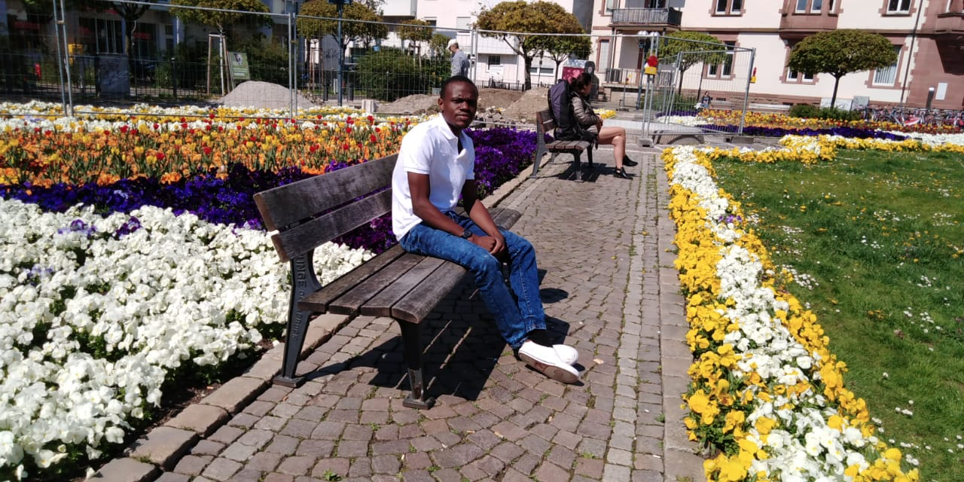
Abbildung 9: Bonding With Nature at Kolpingplatz

I’m also impressed by the way green spaces such as parks are conserved. For years, our capital city Nairobi has boasted of being the ‘green city in the sun’ because it has a national park and some forested zones. Nonetheless, none of that is as impressive as what I’ve seen in Karlsruhe. Parks probably cover as much land area as the built-up area of the city, which is quite remarkable. I was fortunate to live near the Schloss Park and many free afternoons, I always walked there just to unwind or take in nature. On sunny days, I loved sitting at the edge of the small lake behind the castle and feed the fish with bread crumbs. Had it been in Kenya, I would probably be planning on how to catch one of two fish for a sumptuous dinner.

e) The Master Course

One of the highlights of my semester here was getting the opportunity to be part of an amazing master class. From the first day in class, everyone was willing to show us around and explain everything that we needed to know. The fact that I shared an interest in aspects that transcend classwork with some of the classmates, made things even easier for me. I’m a car fan for instance, and when I needed to buy a spare part to send back home for instance, I knew the right person to ask: Julien.
Even though the content being taught in the masterclass was utterly new to us, the friendly nature of our classmates made things seem a little easier. Our integration and participation in group work meant we had to actively participate in creating mind maps and all that, something that personally broadened my body of knowledge. I can proudly boast to my friends back home that I know a thing or two about technical communication even though at first it seemed unrelated and irrelevant to my course. Dennis, Valeria, and Evelyn were particularly helpful. Evelyn in particular, always took time to explain the difficult DITA and Oxygen concepts to me.

My Bad Experiences

My stay here has not been without its fair share of bad experiences. Fortunately, I had been forewarned about them before I came, so I really didn’t take them to heart. Here are some of the not-so-good ‘things’ and experiences that I encountered.

a) Racism

I always looked upon Germany as the epitome of social and cultural enlightment in Western Europe. The last thing that I expected was to be a victim of racial abuse while here. It’s an incident that I deliberately chose to wipe out of my mind lest it erases all the memories of the good time I’ve had here. Therefore, I won’t dwell much on it. I encountered some xenophobic bastards one evening while minding my own business. One of them called me a monkey outright and to the amusement of his friends, went ahead to tell me that I’d be better off in the Amazon. I’ve never felt that hurt in my life. That evening, I was ready to go back home where no one cares about how I look. In some way, the incident killed my spirit and the boundless enthusiasm that I had towards life in Germany.

b) The Language Barrier

Germans are proud of their language, and they are always ready to show that to the rest of the world. One of my biggest challenges at the beginning before I learn some German was the language barrier. I couldn’t just understand why everything was in German, including product descriptions on basic items at the supermarket. Sometimes, I would buy the wrong things without even realizing it. During my first week here, there’s this time I bought tea strainers at the supermarket while thinking that it was a box of tea bags. I still laugh at myself whenever that incident comes to mind. With time however, I’ve been able to rise about the language deficiency, and I can easily find my way around here. Everyone that I know here speaks fairly good English, so it’s easy to communicate and interact with everyone. Hopefully, I will sign up for a German language class when I get back to Kenya so that I polish my written and spoken skills further.

c) Falling Ill

I fell ill three times during my stay. The first time, I had a bad flu in late March. I got some over the counter medication, and it went away after a couple of days. In the second instance, I developed skin rash, which resulted from lots of animal protein. I have since cut down my consumption of animal proteins, but I can never go the vegan way. In the third instance, I really can’t tell what was wrong. I woke up one morning with half of my face swollen. One doctor diagnosed an eye infection, another thought it was just an inflammation, while the third one thought it was abscess. I decided not to take any of the medication prescribed to me and again, I was lucky that my eyes got better after one week.
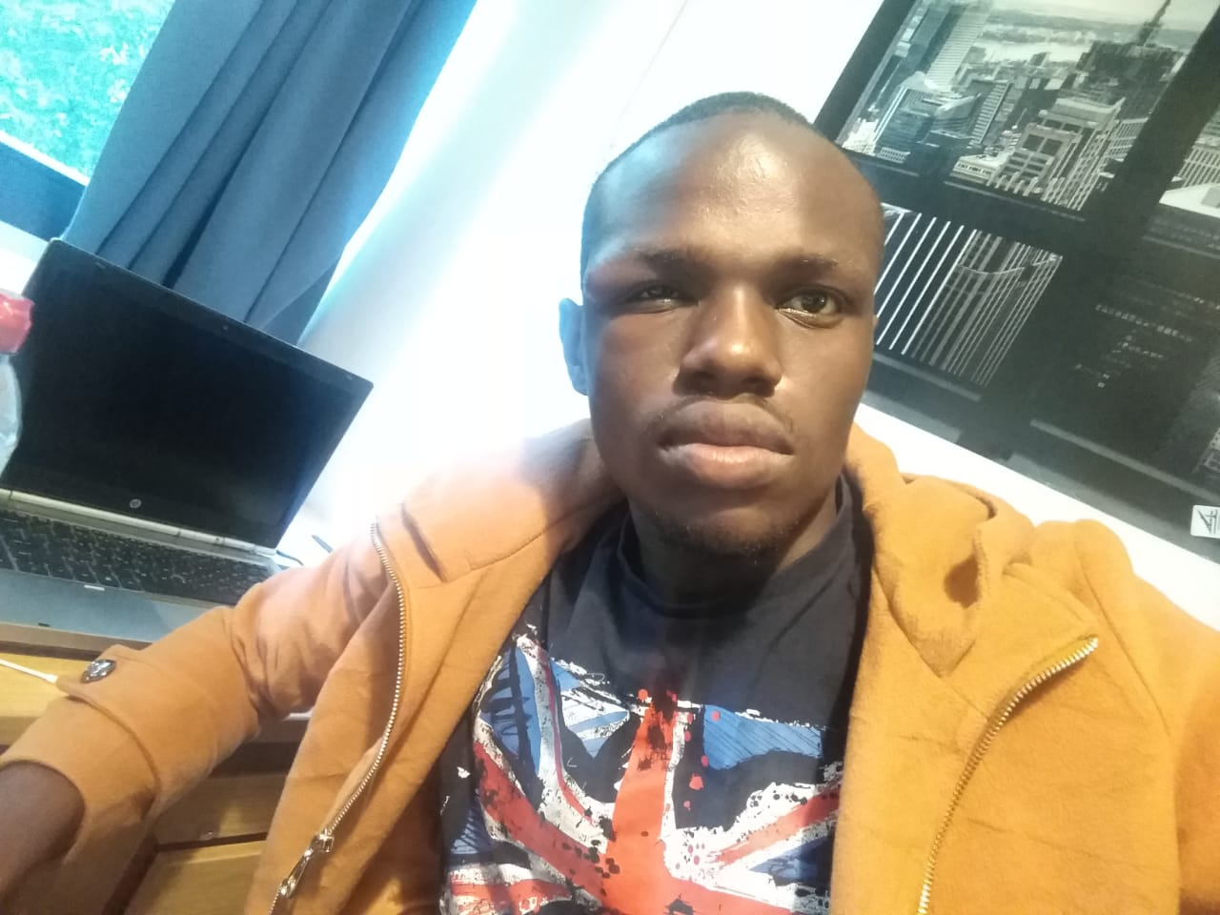
Abbildung 10: Mysterious Eye Disease

Academic Engagements

As part of the 3rd ADDI sub-project, I was required to visit selected courses of the international study program besides visiting a German language course for the entirety of the semester. I choose to attend the following courses: Design Thinking, Presentation Skills, Information Architecture, German Language, and Microeconomics.

The Design Thinking

This course focused on work processes can help us systematically extract, teach, learn and apply these human-centered techniques to solve problems in a creative and innovative way – in our designs, in our businesses, in our countries, in our lives. The tutor was Mr. Alexander Tittel. His classes were quite engaging, and he always sought to make us understand how design thinking touches on all aspects of our lives. I thoroughly enjoyed being part of the class due to the proactive nature of the sessions. For instance, we were required to individually designed wallets for our partners based on empathy.
The class of ten comprised two Kenyans, a Pakistani, a Swiss-Brazilian, a German, a Belgian brunette, and three Indians. The multicultural nature of the class came in handy because we were able to harness our synergies to come up with incredible products at the end of the semester. For instance, my group came up with Moti-Tricks, a learning motivation mobile app, which we intend to develop further in coming months.

Information Architecture

This was the anchor course of the exchange program. Prof. Closs was in-charge of the class. Initially, everything seemed strange to me by virtue of the fact that I have an academic background in the social sciences rather than the pseudo sciences. Fortunately, I had supportive classmates who went over and above their obligation to us, and ensured that were always grasped what was taught. Being part of the education group with the girls was also an eye-opener. I may not have participated that much in the group work for various reasons, but I really learnt a lot. And I will always be grateful for the fact that they welcomed me into an all-girl group with open arms.

Presentation Skills

This was arguably the best and my most engaging course. We make presentations in our daily lives, be it formal or informal. I had always lacked soft skills, such as inter-personal and social skills, communication skills, and presentation skills. Being part of this amazing course imparted me with this skills. During the course, each of us was required to choose any topic, and make a presentation around it. The presentations were recorded, and it was weird watching a video of myself thereafter. I believe I’m now a better communicator than I was, and that I can face any audience. The course was delivered by Mrs. Stefanie Obergfell.

Microeconomics

This course was delivered by Dr. Karl-Heinz Thielmann. I chose to pursue it because I studied economics for two years during my bachelors in addition to the fact that I’m a qualified public accountant. Unfortunately, this familiarity bred boredom because I was familiar with everything that was taught in class (watching a movie for the second time isn’t as exciting as the first time, right?). As a result, I dropped out of the class after the second week. By then, it was too late to register for a replacement course. So, I always had some time off on Tuesday mornings.

Seminars/Conferences/Trainings Attended

I attended a couple of meetings organized by the International office at HsKA. I found these meetings to be quite intriguing because they gave me the opportunity to meet students from other parts of the world.
On 15th and 16th May, I attended the SAP Conference at St. Leon Rot, a small town near Heidelberg. Being there was quite an eye-opener because I got to interact with professionals from different fields. The discussions centered on the subject of science fiction, and I was particularly interested in conversations related to ethical issues that arise from the wide scale adoption of virtual assistants such as chatbots. That’s definitely one conference that I’ll wish to attend again in future.
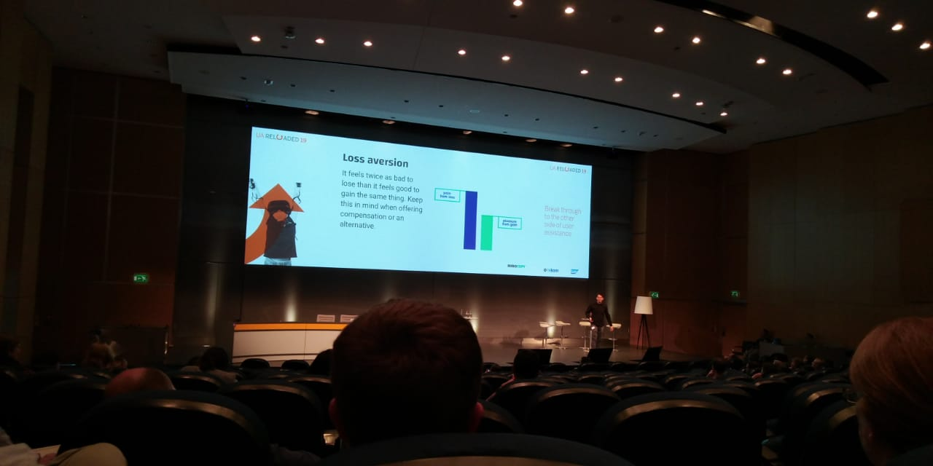
Abbildung 12: Inside the Auditorium during the SAP conference

Places Visited in Germany

I believe that apart from my academic engagements, I also had the obligation to visit a couple of places within and beyond Baden Württemberg. I am an outdoors person, and therefore, I was always out visiting different places in the city, restaurants, and reveling in the nightlife. Just like any typical 25-year old, I visited a couple night clubs around the city.
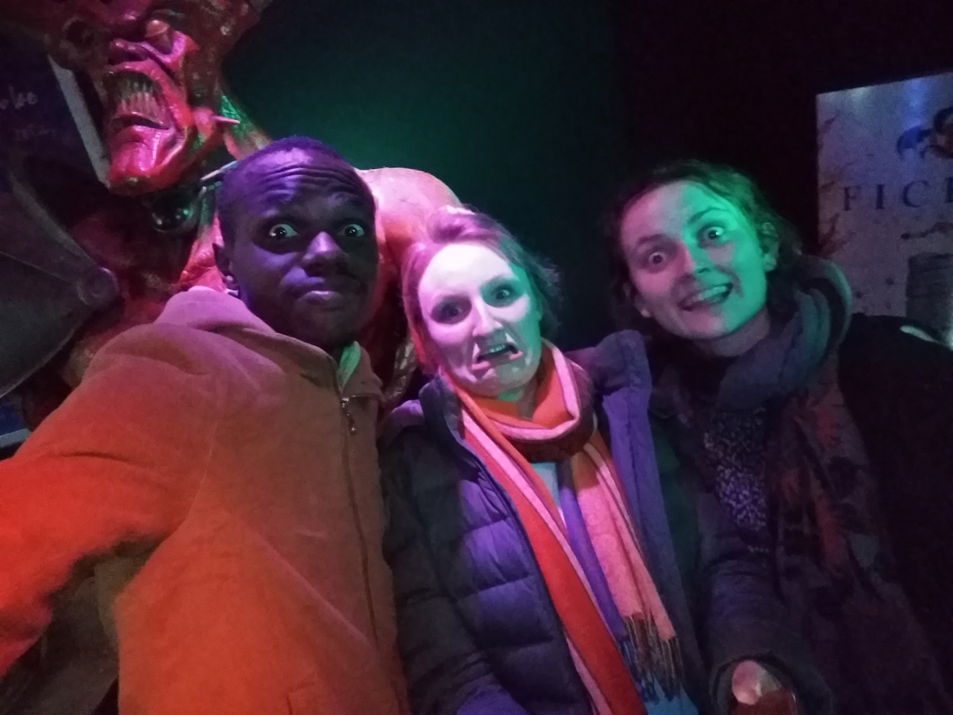
Abbildung 13: Unverschamt with friends

I was also able to visit cities around Karlsruhe. These include Pforzheim, Mannheim, Baden-Baden, Heidelberg, Mannheim, Germersheim, Heilbronn, Ulm, Rastatt, Kehl, Ettlingen, and Bad Herrenalb among others. Of these cities, Bad Herrenalb was the most beautiful due to its hilly and mountainous surroundings, various small rivers, a nice park in the town center, and numerous ice cream parlors.
Heilbronn was also outstanding, largely because I went there at a time when the flower fair was just taking off and the city was in full splendor. Pforzheim and Mannheim were the ugliest of the cities that I visited.
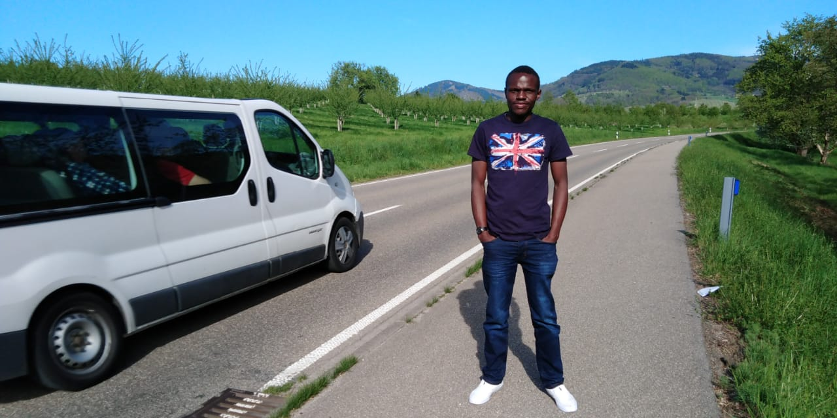
Abbildung 14: Visiting Baden Baden

Beyond Baden Württemberg, I went to Cologne to meet a friend from primary school. I travelled to France just before Spring School to meet my twin sister who was visiting the country, Belgium, and Luxemburg for work-related assignments. It felt good catching up with her and her colleagues, and we also had champagne to our fill. In the course of my stay, I developed a liking for Karlsruher SC. Hadiko is a stone-throw distance away from the team’s home ground, and I’ve attended a couple of matches as a result.

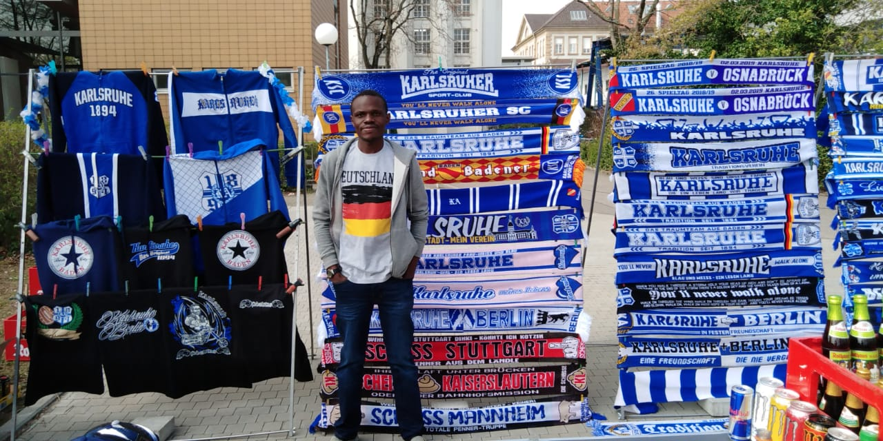
Abbildung 15: Outside the Stadium on a typical matchday

Despite being a new fan, I was delighted when the team got promoted to Bundesliga 2. I will definitely be following its performance keenly even when I go back to Kenya.
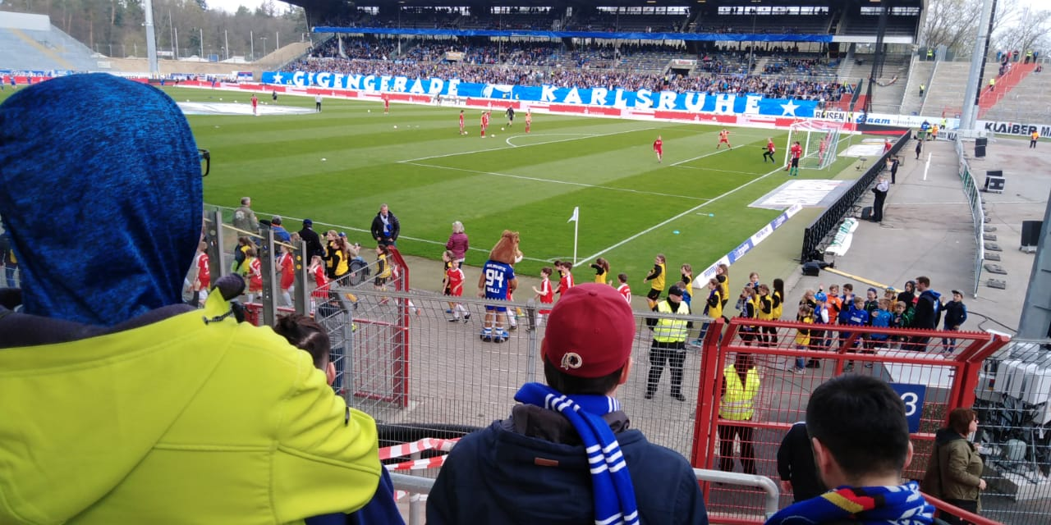
Abbildung 16: The Electric Atmosphere Inside the Stadium before kickoff

Lessons to Take Home

- Environmental Conservation and Proper Waste Disposal
- The importance of technical communication to anyone with aspiring interests in academia
- Self-Management- I can now survive on my own.
- Insights on how to improve the WEIKE project especially when it comes to sustainability.

What I Miss the Most about Kilifi and Kenya

- The warm weather
- Fresh food
- The beach
- Tusker Baridi
- Nyama choma
- The long drives to Western Kenya to visit my folks.

Acknowledgements

- The BWS Team for sponsoring the exchange program
- Prof. Closs and Edith for coordinating our trip
- Simone Martin and Belinda for easing us into life in Germany.
- Members of the Master Class. They were simply superb.

