KENYA -GERMANY EXCHANGE

ANN WANJIRU MWANGI

23/03/2018-13/06/2018
A report of my Germany experience in comparison to my home country Kenya.

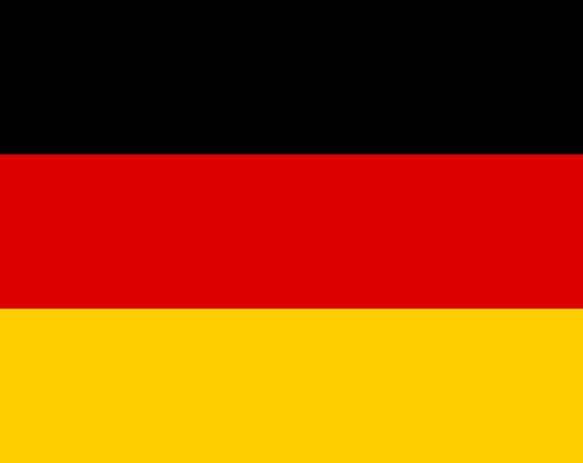

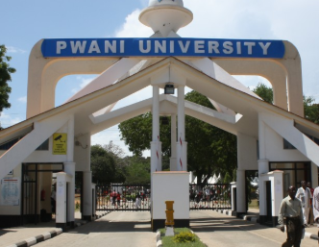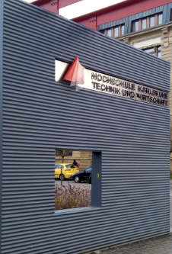

WEATHER
Having arrived during the last days of winter I didn’t have the chance to experience some snow but even then 2 degrees Celsius at Frankfurt was too cold as compared to the 27° in the coast of Kenya.
For once I experienced extreme cold as opposed to the extreme hot temperatures in Kilifi which at times worsens to droughts.
I only read equinox in the books but experienced it for the first time on 23rdMarch when I arrived in Germany and was excited about changing the clock one hour before which be recovered in September when there will be autumn equinox.
The shorter nights in summer was also an exciting feature because darkness sets in at around 10 pm and the sun rises about 6 am.

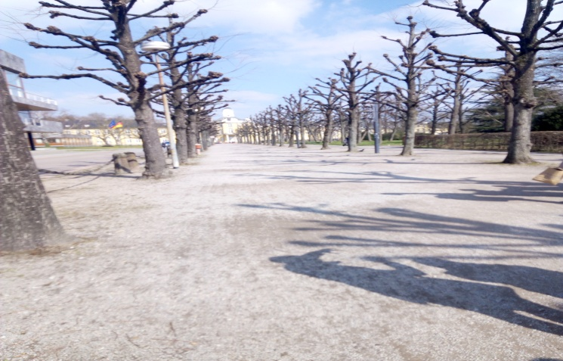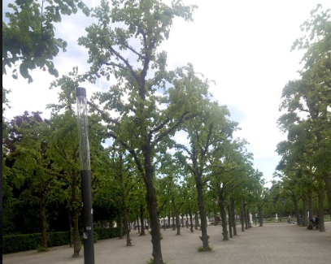
Trees during the winter and the same trees during the summer.

TRAFFIC
Travelling using Flix bus was so great due to less traffic, good roads with no bumps, less hooting and discipline for all the road users as compared to Kenya with so many vehicles on the roads, motorcycles and tuktuks leading to traffic jams and delays to appointments especially in big towns or cities like Nairobi and Mombasa and often so many accidents occur due to competition by the road users.
Use of machines to pay for tram use is of great convenience since there is no conflicts in the money exchange process. In Kenya public transport is paid using cash and sometimes money is lost during these transactions for instance using a big note to pay one has to constantly remind the conductor about 2-3 times for change otherwise he/she just gets away with it.

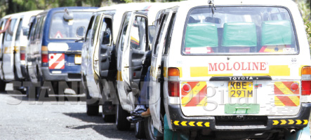
Means of public transport in Kenya
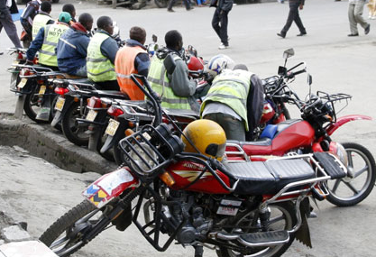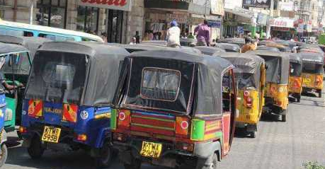Motorcycles and three passenger tuktuks in Kenya.

TRAM USE
Movements around the city are simplified by the tram use and the method of acquiring tickets using machines and the discipline of the people surprised me because the there was no regular checkups of the tickets yet people still bought the tickets.
The computerized system of boarding and alighting whereby the stations are announced in the trams so people know when and where to alight unlike in Kenya where we use touts to announce the stations and if one is not careful they just take pass your station and have to find your way back.
Therefore residents and visitors in Germany are assured of stress free movements using public transport.
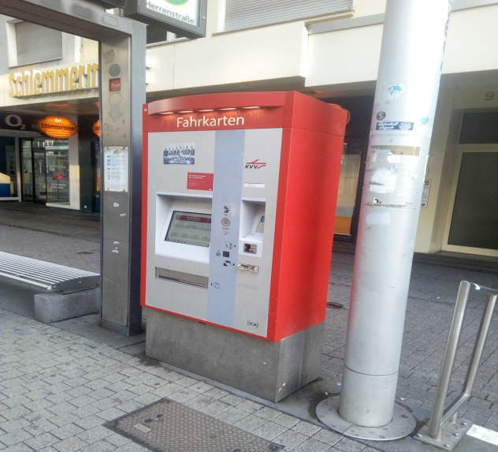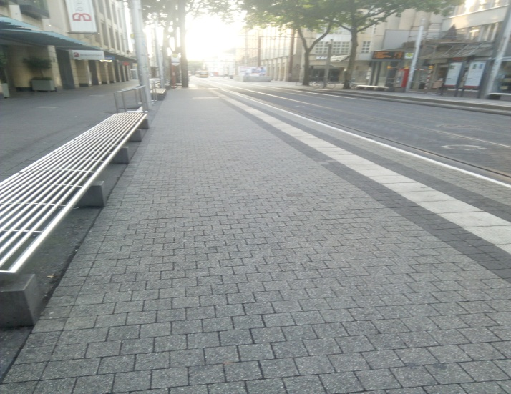
Transport ticket machine Clean streets in the city

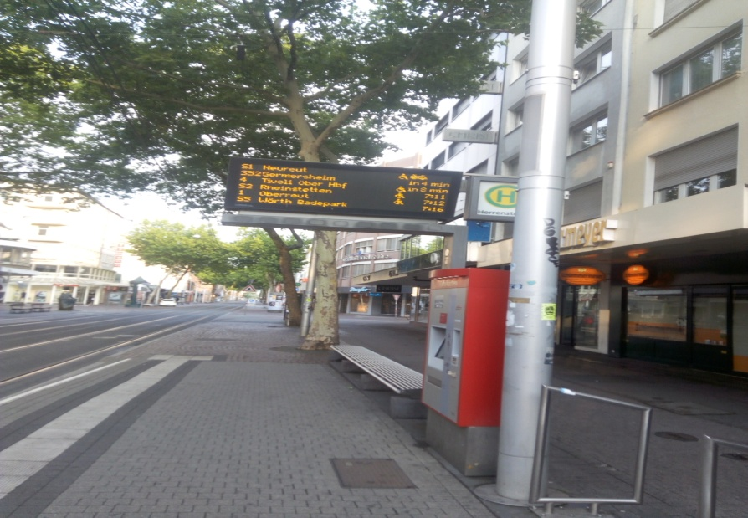
Transport guides at the stations.
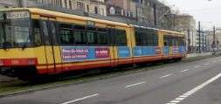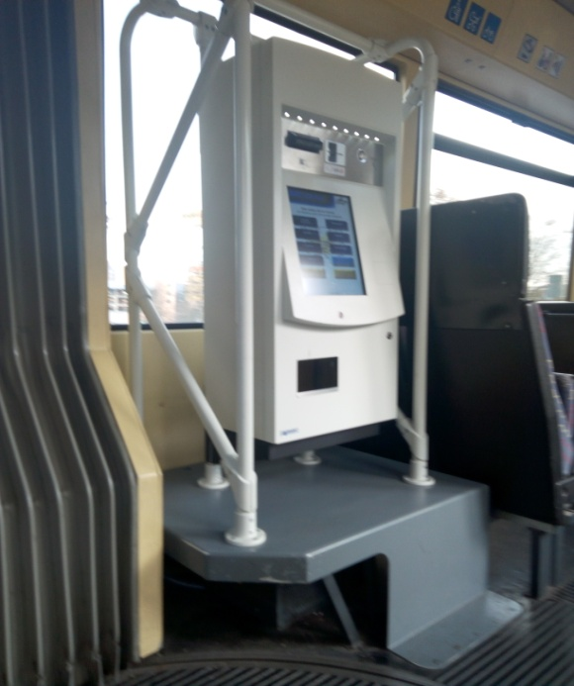 A tram in Germany and a paying machine inside the tram

STREETS
The nature of the streets, so clean ,corrugated and easy to use even in the rainy seasons and simplifying the use of bicycles as opposed to Kenya where the streets can be so rough or slippery during the rainy season which at many times leads to floods again making transport system difficult. In many places during the rainy season in Kenya, the cars often ask for double price for the fare.
Lack of disposed plastics and polythene all over the city makes Karlsruhe even more beautiful.

THE LANGUAGE CHALLENGE
Was so difficult to communicate because everything is in German including Menus in the restaurants, goods in the supermarkets, tram stations, even the computers in the classes are in German as well as the computer keyboards and therefore relied on translations and other times just keep guessing what something could probably mean.
I remember there was a tram strike on 10thApril and it was announced on the radio but again the language challenge. so I went at the station and waited for almost half an hour and then a gentleman came and told the people around something and they started walking and so I just stared at them. Fortunately a lady informed me about the strike and that she was walking back home .I said thanks and I assumed that the group that walked away was headed to the nearest station and so I immediately followed them for about 20 minutes .They didn’t talk to me all through the way so I was not sure whether they were headed to the tram station or to another destination so I just said a short prayer and continued following them and fortunately my instincts were true .we were finally at the tram station. And In the evening I was lucky to be picked by my host.
The following day the strike was over and so I boarded the tram normally but after one station the driver made an announcement and again I did not understand .so I just watched and then everybody got out of the tram and in Swahili we say “mwenye macho haambiwi tazama”meaning a person with eyes should not be told to watch so I just followed suit and got out of the tram as well.
However learning new things is always interesting especially when learning practically, so despite attending a German course I learnt so many things just by observing and listening to conversations.
It is also interesting that as much as German language is so foreign we also share some words in Swahili for instance “shule” in Swahili means school much similar to the German word “Schule” also meaning school.
For other exchange students planning to visit Germany it is wise that they familiarize themselves with the German language considering the fact that Kenya receives so many tourists from Germany therefore some knowledge on language would be so useful.

BUSSINESSES
High stratification of shops such that all common goods are found in one shop for example:
- Electronics
- Food and vegetables
- Body and health hygiene
- Clothes
Unlike in Kenya where it’s possible to find everything under one roof for example in supermarkets, shopping malls.
Closing of shops on Sundays and holidays like the Easter holiday, Labor Day and the Pentecostal week holiday .This is so different in Kenya because on holidays only the formal sectors closes for example banks, and government offices. Other businesses like supermarkets and shopping malls remain open .Actually sales on these particular days are usually higher as people opt to go out, have fun and do shopping.

PLASTIC CANS AND POLYTHENE PAPERS
Recycling of bottles whereby one returns a used plastic bottle and gets some cash for the same. Good way of maintain a clean environment. This is a good practice of ensuring no bottles are thrown everywhere and keeping off health hazards .For instance in Kenya we complain of high rates of malaria infections and of late there was an outbreak of a disease called chikungunya also caused by mosquitoes yet we throw plastic bottles everywhere which when it rains the become breeding sites for mosquitoes and therefore people end being infected.
Separation system of waste is also an interesting aspect for example a bin for papers only, another one for organic materials, and another one for materials that can be recycled. In Kenya all waste is just waste so it is all thrown in one dumpsite which is later collected by the county governments.

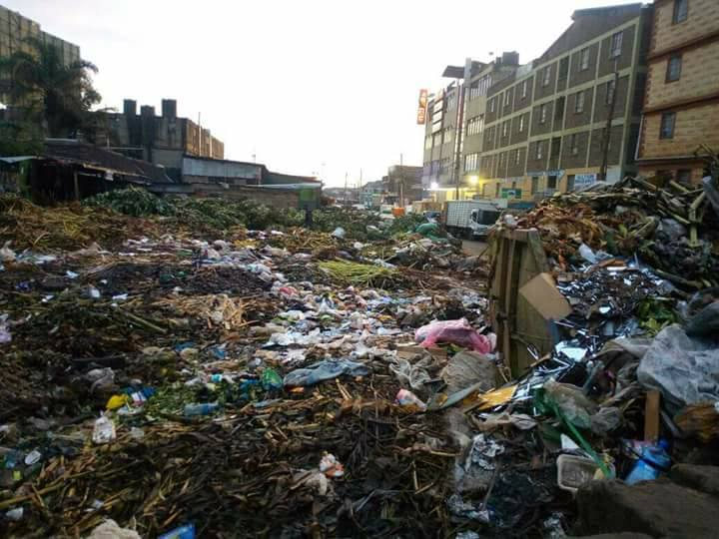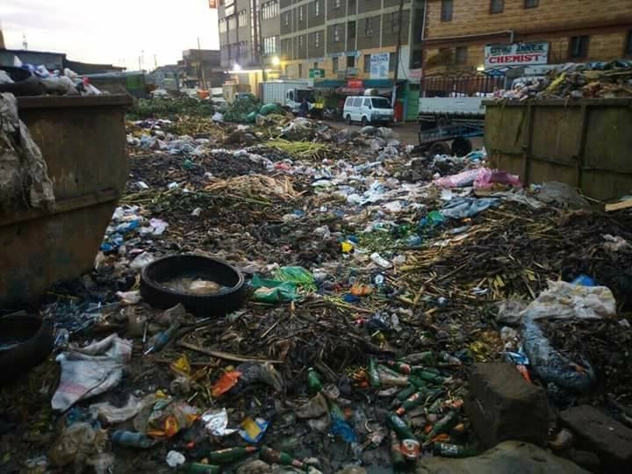
Garbage disposal site in Kenya.
However it is great that after seeing this waste hazard the Government of Kenya banned the use of plastic bags in Kenya with heavy fines or years in prison for those caught using them. Welcome to a cleaner Kenya in a few years!
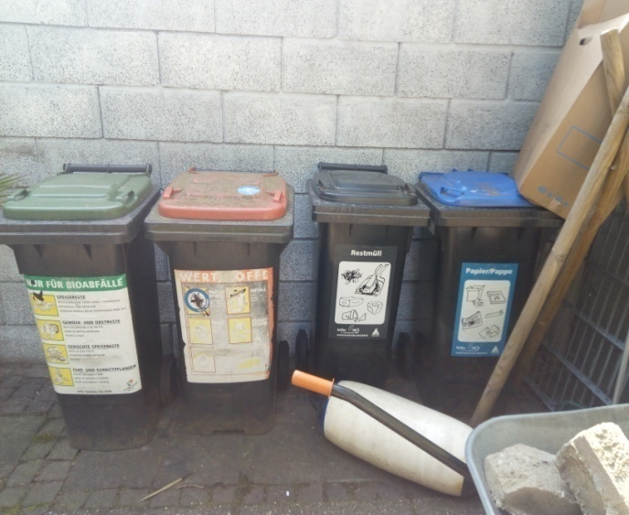
Litter well organized in garbage bins in Germany.

VEHICLES
Numbering of vehicles using states unlike in Kenya where the number plates are begin with K for Kenya apart from Government vehicles which begin with G K meaning Government of Kenya and in Kenya we keep left in Germany they keep right.
I was also surprised that there is no speed limit for vehicles in Germany. In Kenya the speed limit is 8okm /hr which is good so as to control the number of accidents that are caused by over speeding.
FOOD
During the first week it was difficult to find something to eat because of the language barrier since most menus are in English. I actually didn’t like my first meal though because it was trial and error but at least I ate half of it. I actually thank God that I didn’t order pasta with cream because clearly I wouldn’t have even eaten a quarter of it.
Another challenge was getting our typical Kenyan food like ugali ,chapati,and we are used to a lot fresh vegetables from the farms,fresh fish from the ocean and it was thus difficult to get used to buying everything in a supermarket and of course at a higher price.
The language again makes it more difficult to shop for food in supermarkets because most products are written in Deutch.
However with time it became easy to manage on my own as I knew joints where I could get quick food and when am in the house I would cook the food of my preference.
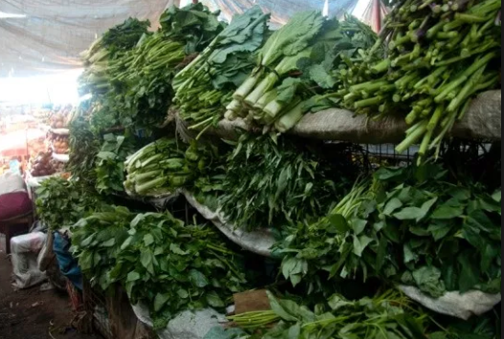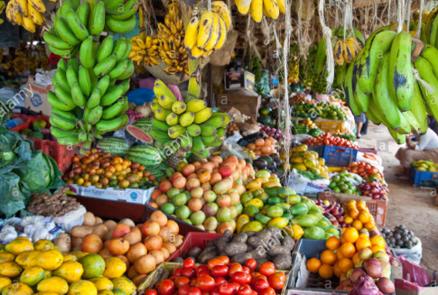
An example of vegetable and fruit stalls in Kenya.

However new experiencing new food was also an interesting aspect and being open minded always creates room for great experiences. For instance I wouldn’t eat mushrooms in my home country because they grow wild but when I saw them in packed in Germany I wanted to try them out and when my host cooked them I couldn’t what I have been missing all throughout my lifetime.

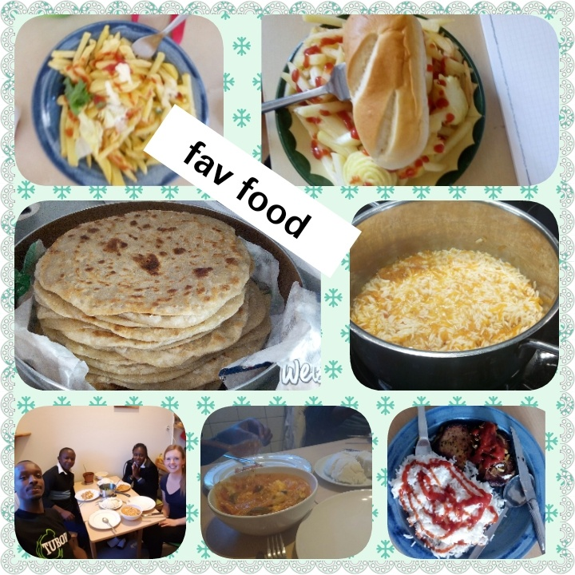
Favorite food which is better when shared with friends.

STUDY ROOMS
The study rooms are great with each fitted with a number of computers and all computers fitted with internet and this provides a good study tool for students .They also make it simple when demonstrating something in the computer and all the students can follow.
Mainly back at my university we depend on individual laptops though we have one room fitted with computers but considering the population at the university, the room is always fully occupied.
The study methods are quite similar where we combine lectures with presentations and although the classes I attended were in German I enjoyed listening as it quickened my knowledge in Deutch .The interactions between the professors and the confidence of the students also made me build my confidence when giving presentations.
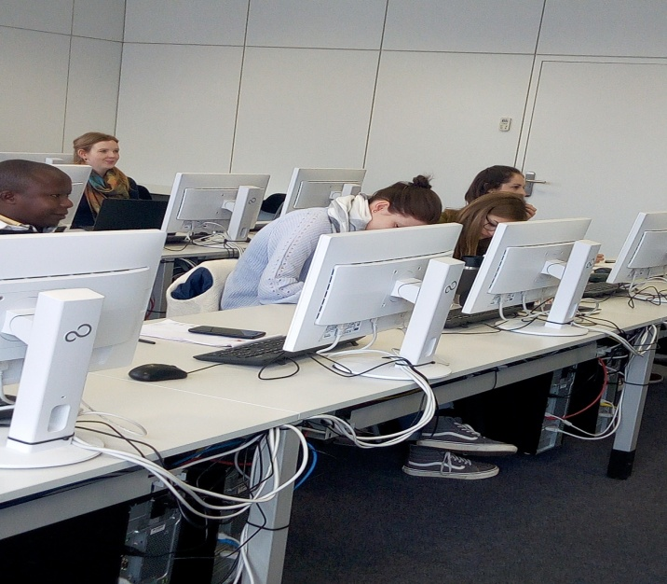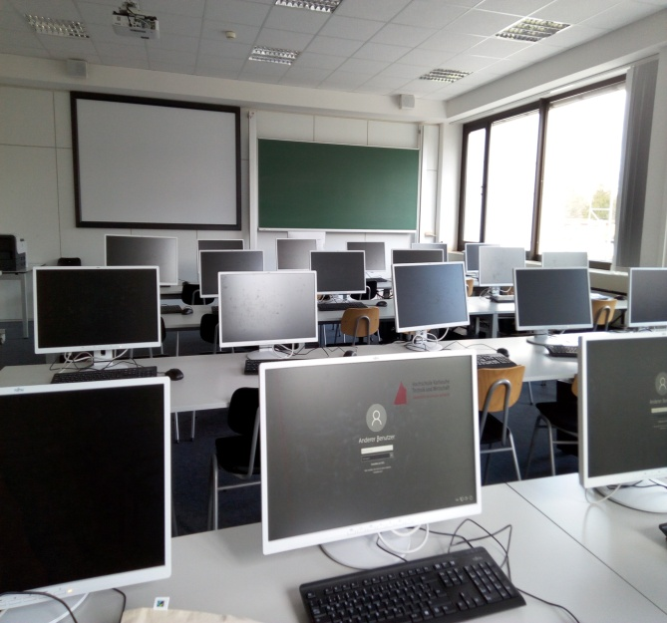
Study rooms in HsKA

BUILDINGS
The typical way of building storey houses is a good way of utilizing land resource instead of constructing every house on an individual space and as a result decongesting the city.
The use of carvings and art also add to the beauty of the city making it so attractive. This was also common in Heidelberg where all buildings have a curving most which of which carry a story with them.
The building design of the Karsruhe city is interesting that is arrangement of the sun rays.
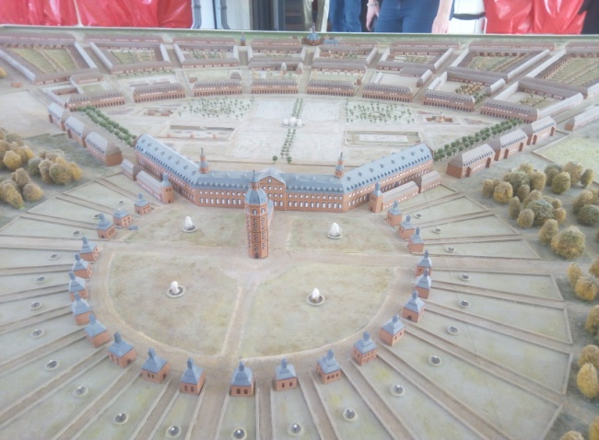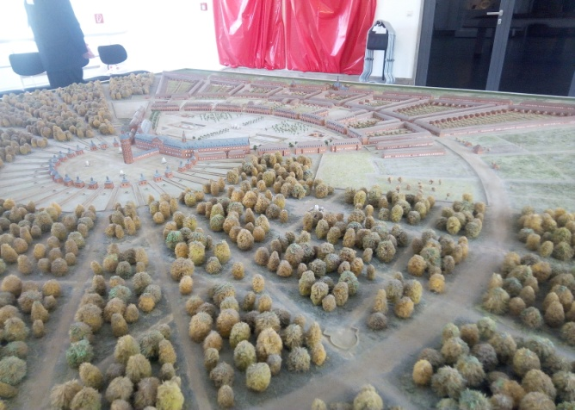
The design of Karlsruhe like the suns rays

TECHNOLOGY
The use of computerized machinery in carrying out various activities makes work easier and saves a lot of time .For instance when I started staying with my host and after some time I offered to wash the dishes and she just told me don’t worry there is a dish washer and I was so surprised that we spend so much time washing dishes by hand when a machine can just do that.
I was also happy that I wouldn’t have to wash my clothes by hand as am used to in Kenyaand for once I can just keep my nails long.
I also saw a modern car wash and I actually stood there for some minutes watching the technology.
I also saw a machine pruning tree branches from the ground whereas in Kenya one has to climb the tree with a power saw to do the same.

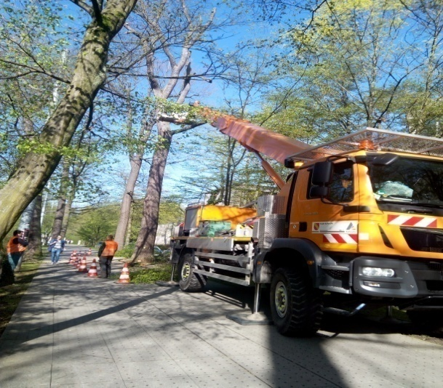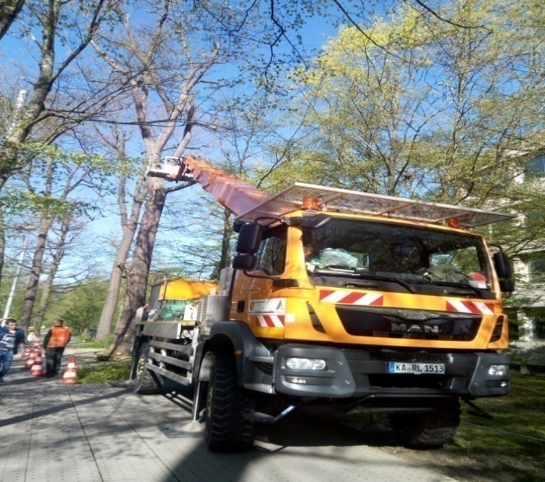
Some tree pruning machines

EDUCATION SYSTEM
The education system is also interesting and quite different. In Kenya whereby we have an 8-4-4 system .That is Eight years in primary school, 4 years in High school and 4 years in the university.
The German primary and secondary school system is a rather complicated one in which there are sometimes as many as five different kinds of secondary schools (usually starting at grade 5) and various paths leading to academic higher education, advanced technical training or a trade basically a three-class system that divides students into three different tracks: (1) Gymnasium for bright students headed for college, (2) Realschule for the next step down, kids headed for average or better white-collar positions, and (3) Hauptschule for the bottom tier, generally aimed at the trades and blue-collar jobs. By the age of 10 most pupils in Germany have been put on one of these three educational tracks.
On the hand in Kenya one has to study for 8 years and then sit for a national exam which would determine to which Secondary school one can attend. One exam is not the best measure to gauge a student’s capability.
This is interesting and at least one can build up a career and expertise from young age depending on abilities, skills and interests’ .Kenya can borrow from this method.
It is also interesting that students in Germany go to school in home clothes as opposed to uniforms in Kenya up to Secondary level.

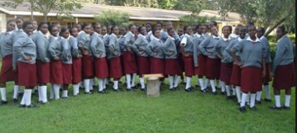
An example of school uniform in Kenya: Above my former secondary school; Kabare Girls.
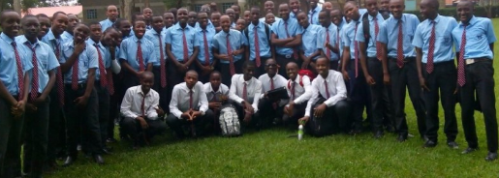

PROJECT WORK AND COURSES.
Having a chance to be involved in the Women Empowerment in Kenya (WEIKE) Project is great since we try and find the best way to empower the women in Kenya and one of them is through agriculture.
With the help of other master’s students in the class I have been able to learn how to enter information into the Oxygen tool which they create as part of the Information architecture course.
Being involved in the Agriculture group we were able to create some useful information on how to grow various plants in Kenya. The information is created depending on different target groups that is: the women, the trainers and the land owners, which I believe is a good step into empowering women in Kenya.
I was glad to be involved in the project since I have a good background information on agriculture having been brought up in an agricultural family and having worked at the National Drought Management Authority in Kilifi which deals with empowering farmers in Kilifi County despite the harsh weather conditions such as prolonged droughts and floods during the rainy seasons.
In addition being involved in creating a learning platform for students that is KARLIFI for students in Karlsruhe and Kilifi is a good development as students can easily share ideas, learn and circulate information and will be glad to pass the knowledge back at my home university.
It is also a good step and a pace setter for other students both in Kilifi and Germany who will follow this example to come up with other helpful ideas.
However the main challenge that I faced during the classroom work was the language barrier where most presentations are in German and therefore some information would just pass .But all the same listening to the presentations from the students and how they interacted with their professors built my courage and later on I could express myself without fear.
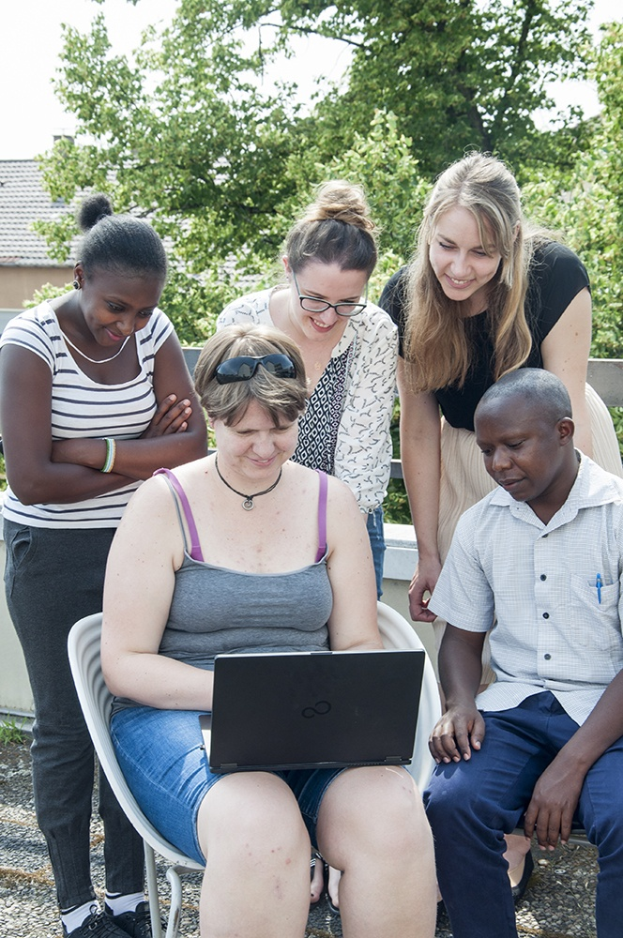 Group work with the KARLIFI Platform group.
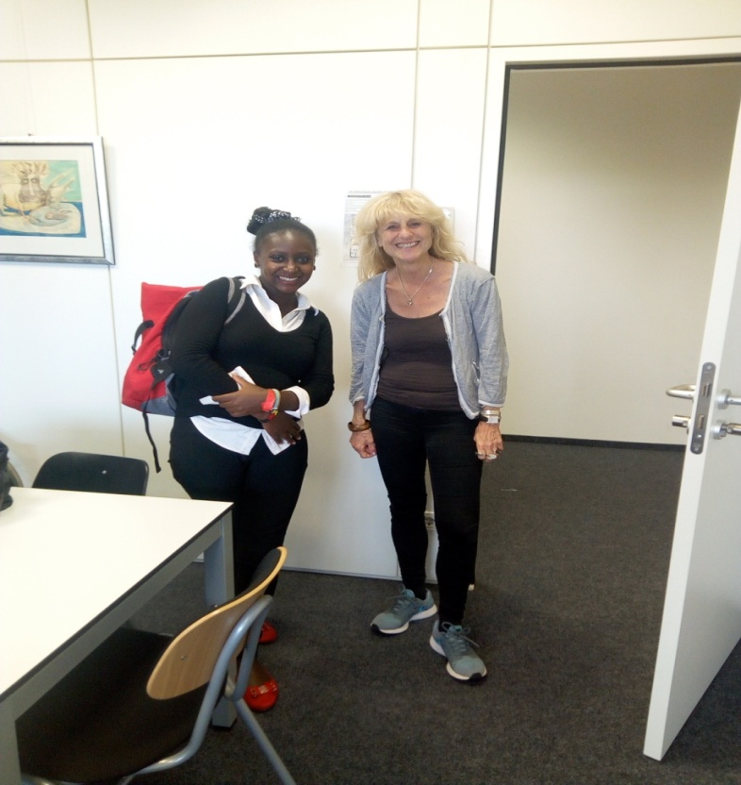
Interactive moments with Prof.Sissi
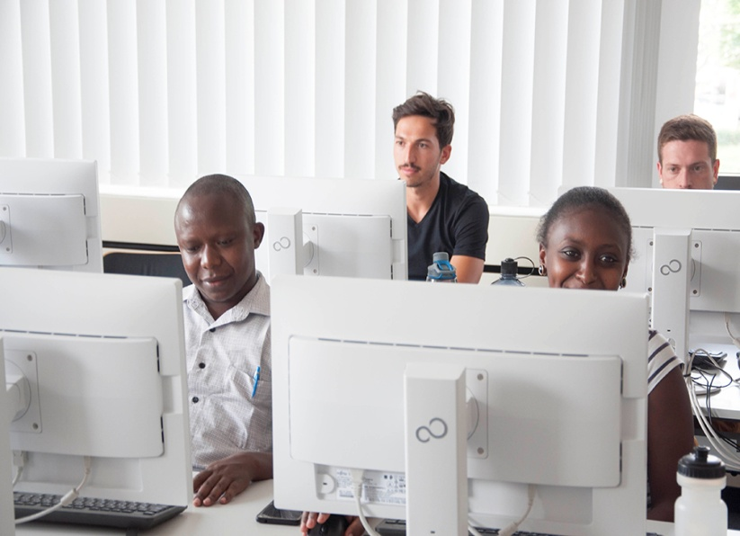
Listening to lectures at the masters course.

‘FREMDSEIN’ WORKSHOP
During my stay in Germany I was privileged to attend a workshop which was named “fremdsein’, which means the state of feeling foreign in a different country.
It was interesting as it involved most international students in Germany as well as Germans who have visited other countries. In the workshop people discussed about things which made them feel strange and those which made them feel at ‘home’.This was a healthy discussion because we later understood that it is natural to feel strange and the best ways to cope.
Some of the issues included,:food,language,culture,weather,social interactions,e.t.c.
It was also interesting to meet other international students and learn about their experience in Germany.
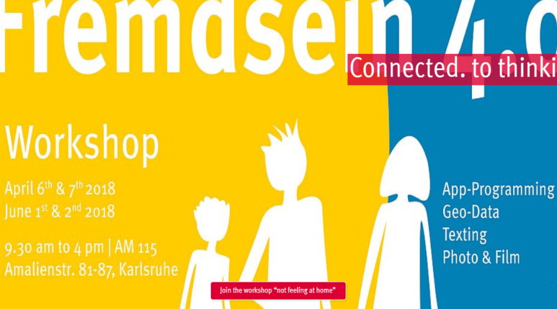

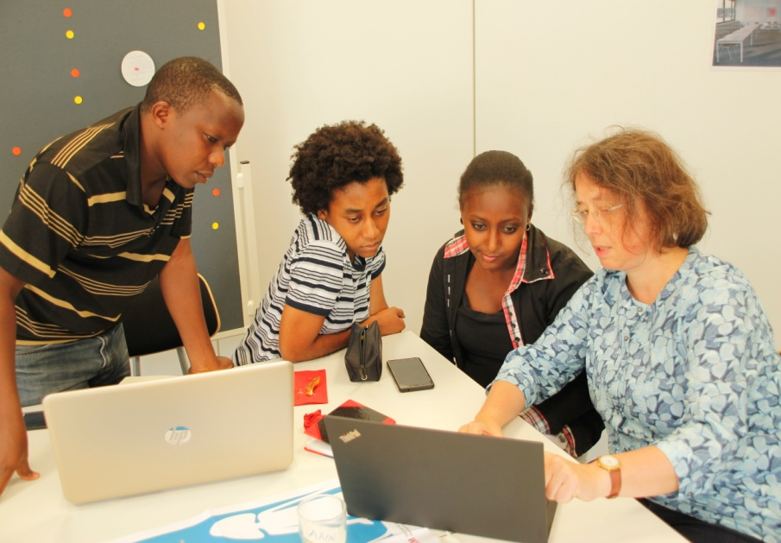
Group work during the Fremdsein workshop

GERMAN COURSE A1.1
Attending a German course was the best thing that happened during my stay in Germany.It involves introduction to basic rules of grammar and learning of basic things such as :
- How to introduce oneself
- How to ask or give for directions
- Numbers, Alphabets and pronunciation.
- Days of the week , and names of months
- Important key features like names of school, the city, the train station etc.
- Important words in a language eg how to say sorry, thank you, welcome .e.t.c
These and many others made life and my experience easier as I could understand a few words in a sentence and know what the conversation is about.
It was also interesting because all the students in class were beginners and therefore pronouncing foreign words was so much fun.

COMPANIES AND WORKING ENVIROMENT
Was lucky to visit some companies around Germany that is Heidelburg and SEW Drive in BruchsaI got a chance to learn about some interesting things for example,
- The Flexi time working schedule that if one is required to work for a particular number of hours in a week one can decide to work extra hours in some days and the take a leave for a day or two.
- Taxes .That taxes paid reduce with marriage and family status .That taxes reduce if one is married and reduce further if one has children.
- Retirement age .The retirement is relatively the same that is 55 years to 60 years and a pension.
- Maternity leave. In Kenya maternity leave is three months while in Germany it is two years.
- Production. Was interesting to learn of some products made in these companies eg car gear boxes and machinery motors .We thought all the products come from China because every product that we use us usually written in “Made in China”.

EXCURSIONS;
Being in Germany I got some interesting chances to visit different places .For instance:
Heidelberg city.
Being an old city we had the chance to go for a city tour who gave some interesting stories about the city, how it began, and various important events that took place in the course of history.
We are had the chance to visit the Heidelberg schloss which as well had its own interesting story as well.

The landscape in Heidelberg is fascinating for instance a river between two hills separated by a bridge which history says was washed more than two times by floods until the people finally built a stone bridge.

The buildings in the city as well as the Schloss are beautiful and one can tell a lot of creativity and advancement as early as the 16th century.

The relationship between political power and the church also caught my mind, whereby the city would worship according to the directions of the ruling duke, For instance there was a church which changed denomination more than 4 times from Lutheran to Catholics and vice versa until at one point it was divided into 2 sides at the center, one part for Catholics and the other side for protestants so as to stop the war between the two.
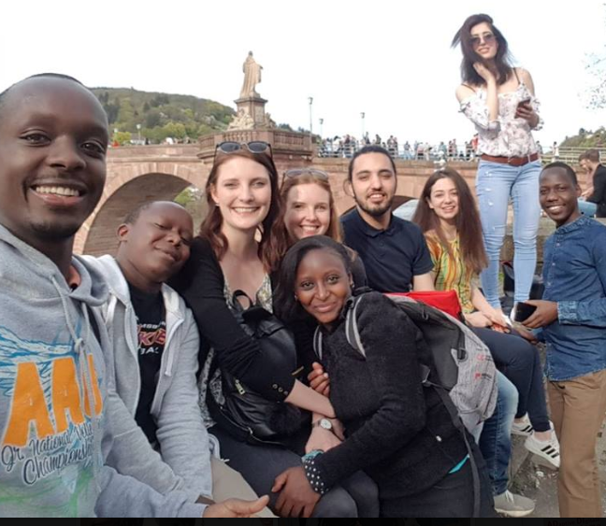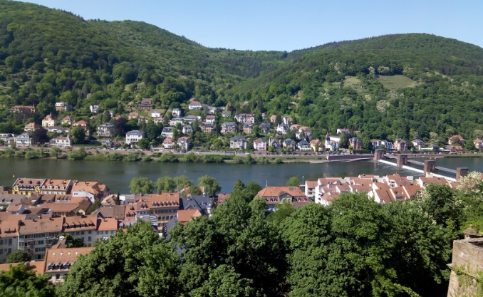

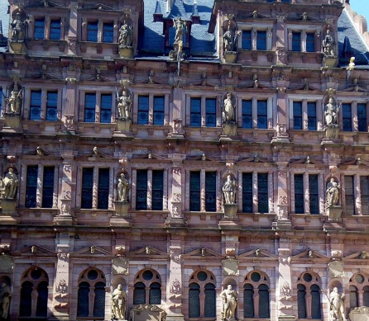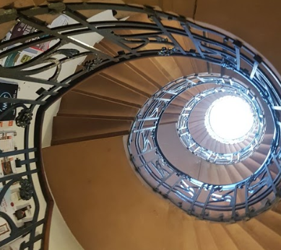

Interesting features at Heidelberg

The Schloss in Karlsruhe.
I regularly visited the castle in Karslruhe which is so beautiful. I had the opportunity to go up the tower which made it possible to get the aerial view of the whole city .It was also possible walk around in the castle to see various things which were as well interesting. The view outside is also fascinating and is therefore a good place for locals and tourists to spend time.

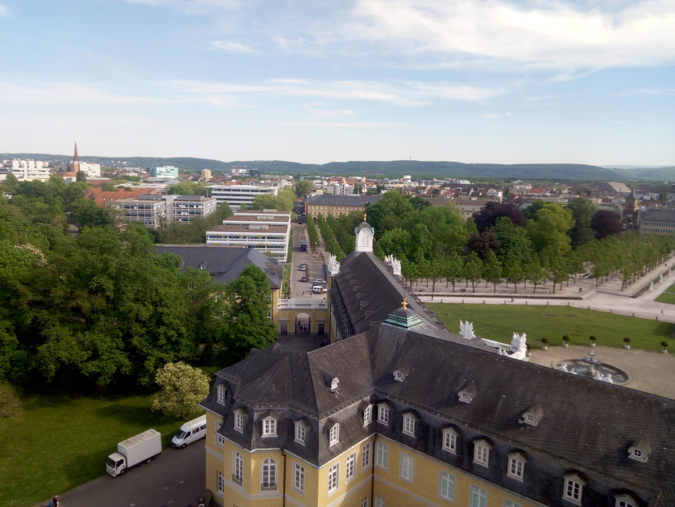

Aerial view of Karlsruhe from the tower at the schloss.
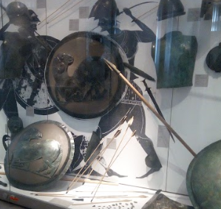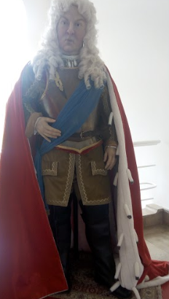
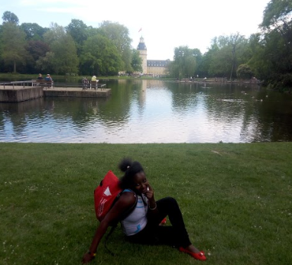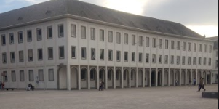

Beautiful Sites at the Schloss

A TRIP TO FRANCE
During my stay in Germany it was possible to visit France with my friends which were also a great experience. The train connection from Germany to France is great and therefore made our travel easy.
It was interesting to note that there were so many black people in France than in Germany.
I also noted a lot of business in the streets for example shoes and clothes in open air market as opposed to Germany, but common phenomena in Kenya.
It is a beautiful place and would therefore recommend others to visit France as well.
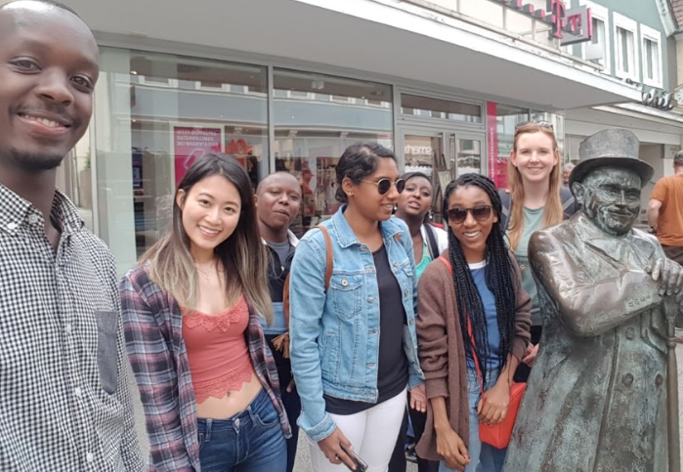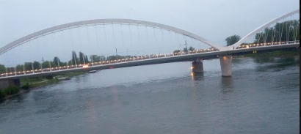
Friends on a visit to France and the bridge at the boarder of Germany and France

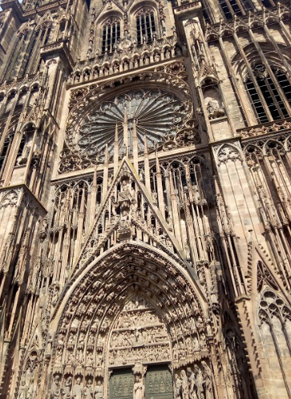
The tallest church in Strasbourg France.

THE VOLKS FEST
Was lucky to attend the Volks Fest in Karlsruhe and saw some captivating activities for both children and the adult.
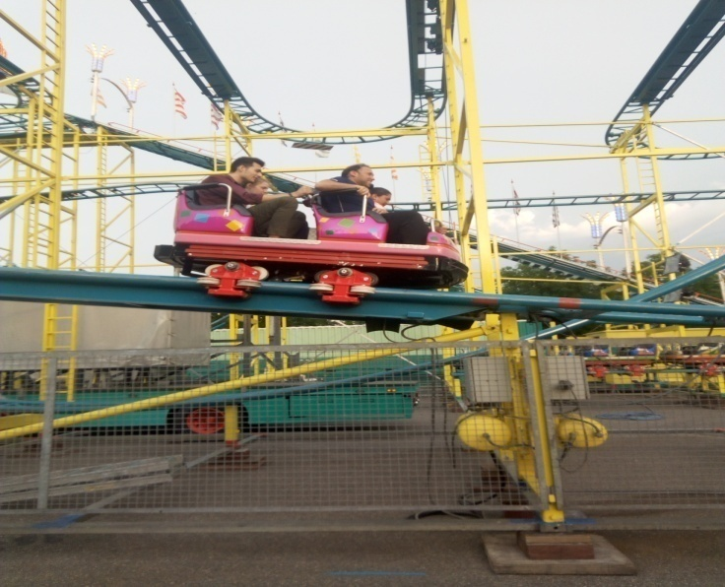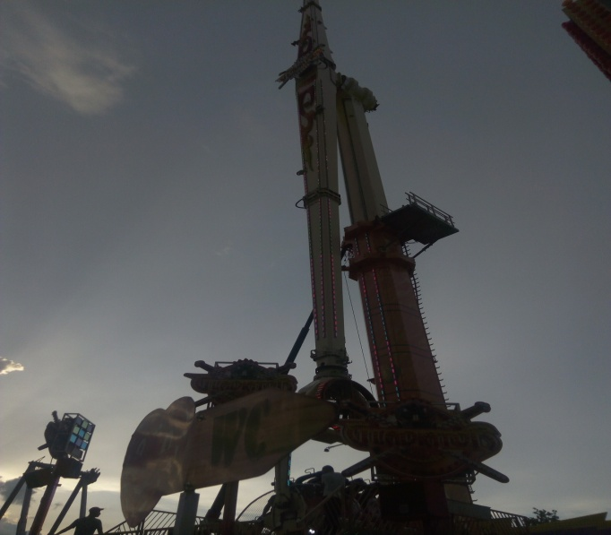
Some of the activities at the Volks Fest.

A TRIP TO BLACK FOREST,BIBERACH AND DURBACH
Had a great opportunity to visit the black forest and Biberach village a hometown of one of my friend and had a chance to see cherry fields and also pick strawberries. It was as also interesting to see other plantations like maize and some other crops in the fields.
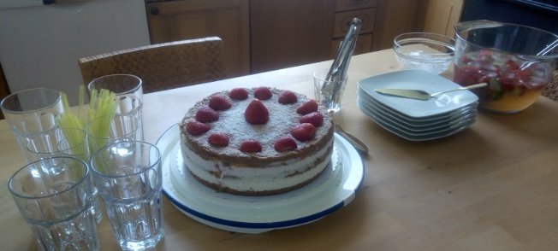
A straw berry cake by Simone’ Father.

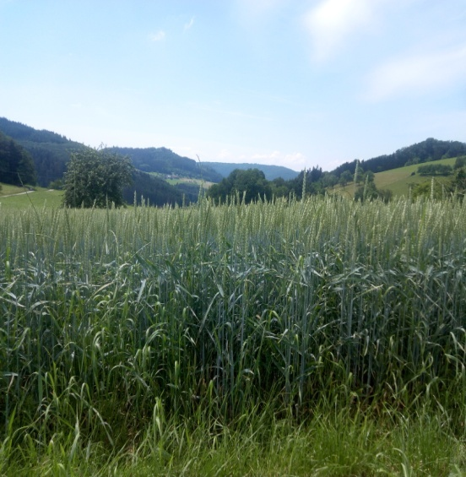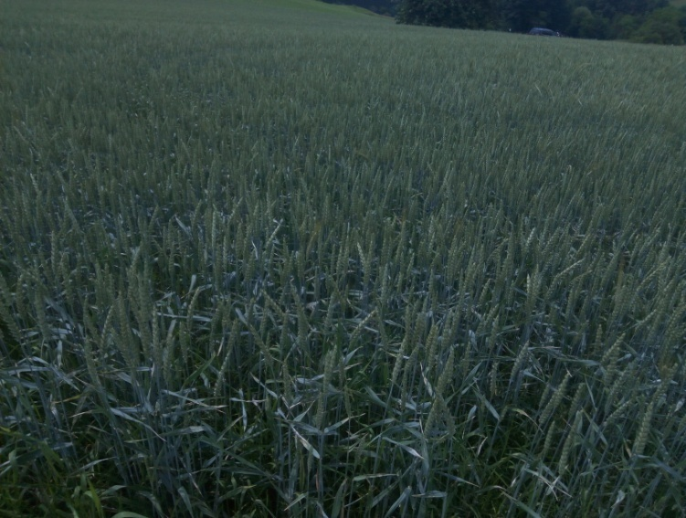

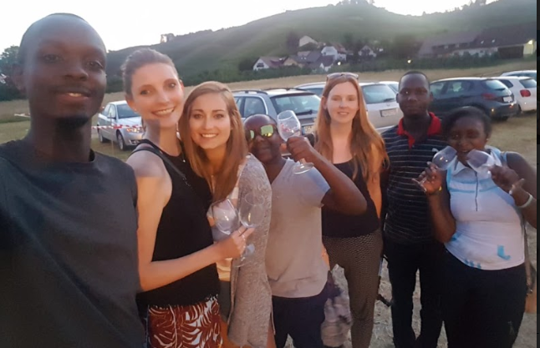
Wine festival at Durbach

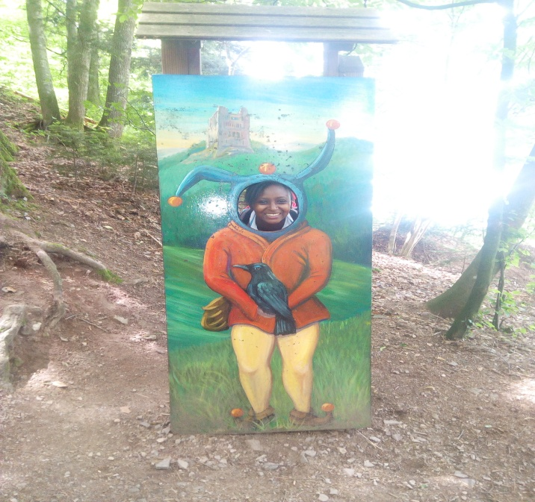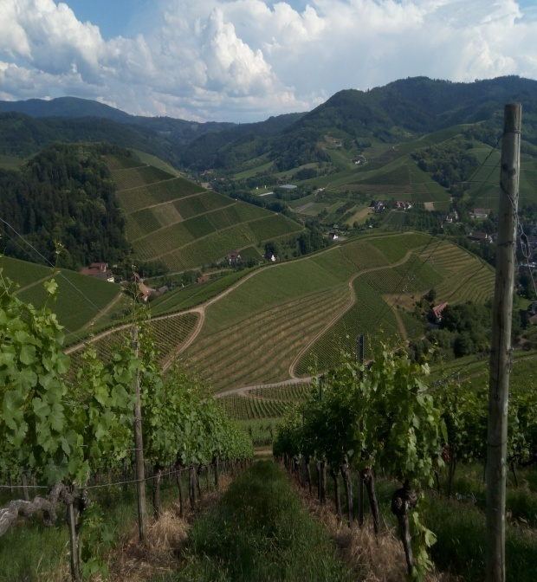
Features in the woods Vineyards at Durbach
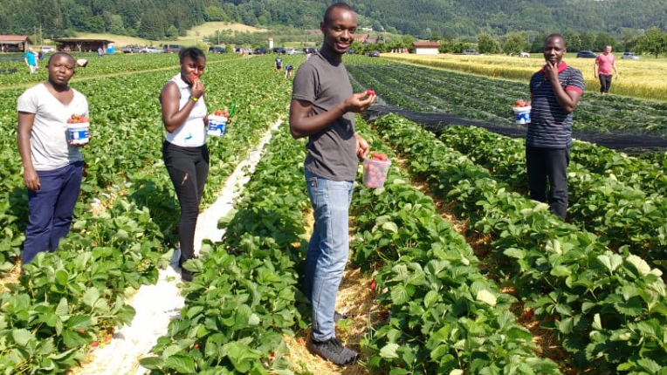
Picking straw berries
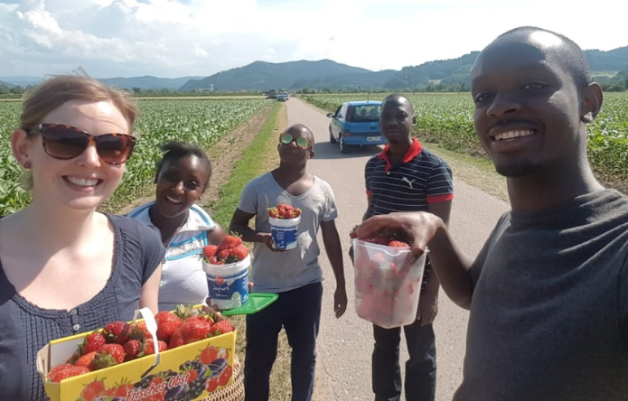
Straw berry picking at Biberach

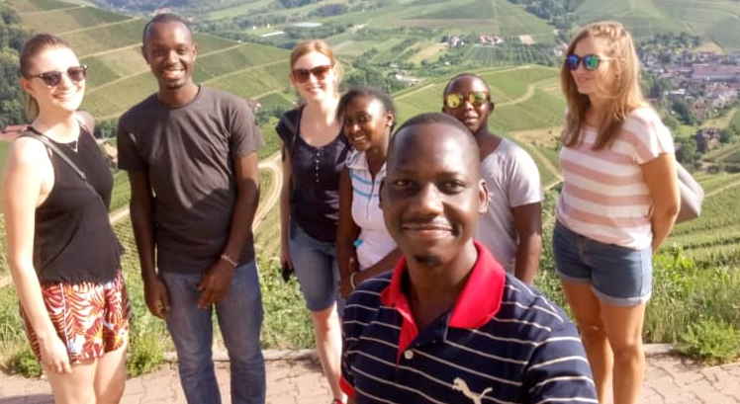Beautiful scenes at Durbach.
A TRIP TO MUNICH
I was privileged to have a chance to visit the city of Munich with Professor Sissi .It was the most overwhelming moment and was looking forward to it .It was also interesting to see agricultural land in Germany, the beautiful lakes in Munich as well as the mountains which I hadn’t seen in Karlsruhe .Most fascinating was to see the Olympic field ,The Technical University of Munich ,The BMW exhibition building, which are really popular and was thus glad to see them in real circumstances.

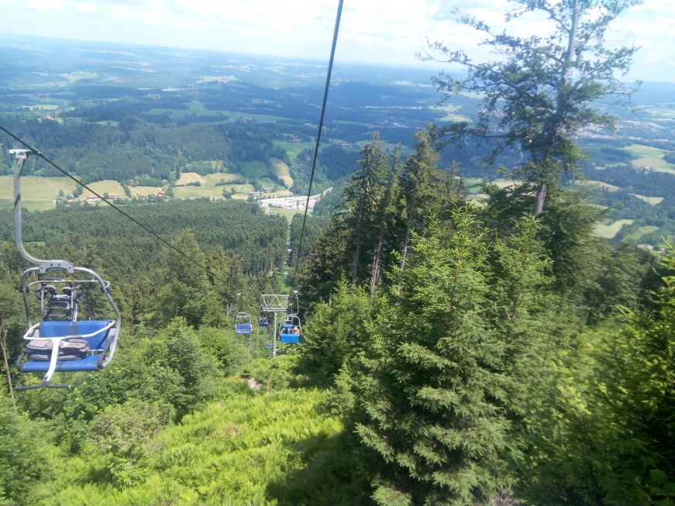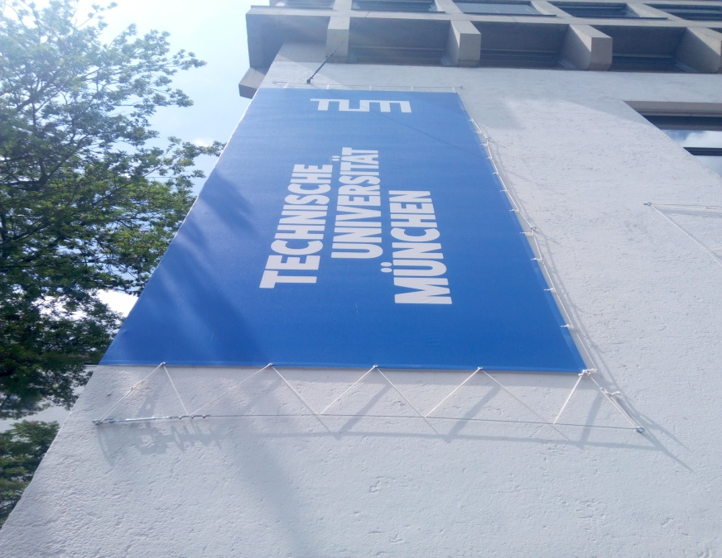
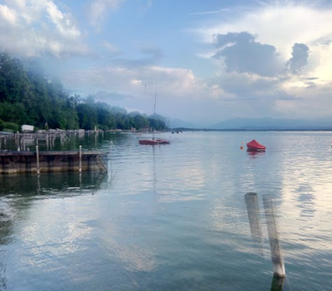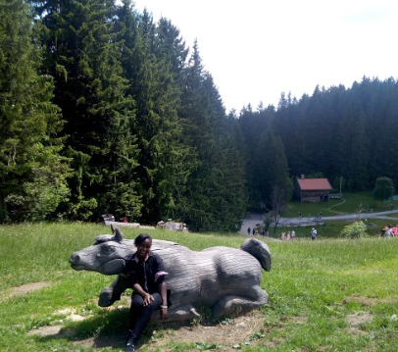
Beautiful sites in Munich.

INTERACTION WITH AMERICAN STUDENTS.
During my stay in Germany I was privileged to interact with American students from the University of Minnesota and had a chance to learn about education in America.
I also got a chance to share about education to German students as well as to the American students.
Together we were able to visit some companies in Germany and learnt a lot about the working environment in Germany and to also learn working environment in America and again compare with Kenya.
For instance it was interesting that most people in the working force in Germany are above 40 years because the population has more aged people and therefore the number of unemployed youths is about 2 to 3%.Kenya on the other hand has the majority of the population being young people and therefore faces a very high level of unemployment at 22 to 23 %.
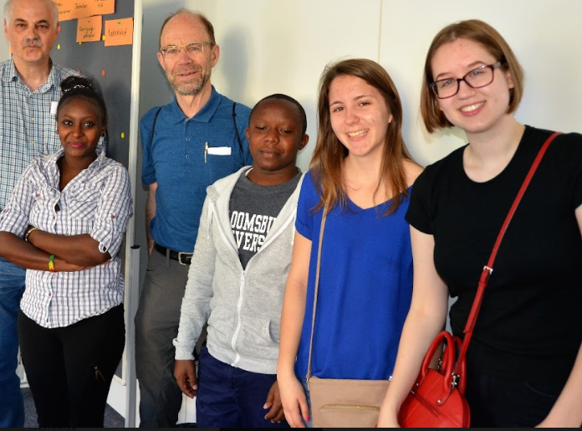
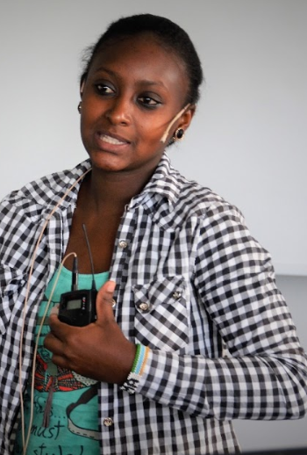
Giving a talk about Kenyan Education.

CONCLUSION
The total experience in Germany was great and adds value to me academically, personal advancement as well as adding to skills in career advancement .Am really grateful to all those that made it possible .Special regards to
- BADEN WÜRTTMBERG STIPENDIUM
- HOCHSCHULE OF KARSRUHE TECHNIK UND WIRTSCHAFT
- MY HOST FAMILY IN KARLSRUHE
- MASTERS CLASS 2018 HsKA
- PWANI UNIVERSITY

DANKE SCHÖN

